Week 1: 08/01/24 | Week 2: 15/01/24 | Week 3: 22/01/24 | Week 4: 29/01/24 | Week 5: 05/02/24
Theme: Birds | Theme: Chinese New Year | Theme: Awesome Series – The Inheritance Cycle | Theme: National Story-telling Week is 30th Jan – 6th Feb | Theme: Children’s Mental Health Week is 5th – 11th Feb
Extracts:  - Birds (non-fiction).  - Magnificent Birds (non-fiction).  - Extraordinary Birds (non-fiction). | Extracts:  - All About China (non-fiction).  - The Kite Runner.  - Chinese New Year: Lets Celebrate (YouTube video). | Extracts:  - Eragon.  - Eldest.  - Brisingr. | Extracts:  - The Chime Seekers.  - Freeze.  - Shadowghast. | Extracts:  - Perfectly Norman (full PB).  - How to Take the Grrrr Out of Anger (non-fiction).  - A Monster Calls.
23 pieces of Tier 2 and Tier 3 vocabulary.  21 retrieval questions.  3 writing challenges. | 26 pieces of Tier 2 and Tier 3 vocabulary.  21 retrieval questions.  3 writing challenges. | 24 pieces of Tier 2 and Tier 3 vocabulary.  21 retrieval questions.  3 writing challenges. | 21 pieces of Tier 2 and Tier 3 vocabulary.  21 retrieval questions.  3 writing challenges. | 21 pieces of Tier 2 and Tier 3 vocabulary.  14 retrieval questions.  3 writing challenges.
16 EXTENSION questions to stretch learners. | 15 EXTENSION questions to stretch learners. | 18 EXTENSION questions to stretch learners. | 12 EXTENSION questions to stretch learners. | 6 EXTENSION questions to stretch learners.
Content Domains covered: 2a, 2b, 2c, 2d, 2e, 2f, 2g, 2h | Content Domains covered: 2a, 2b, 2c, 2d, 2e, 2f, 2g, 2h | Content Domains covered: 2a, 2b, 2c, 2d, 2e, 2f, 2g, 2h | Content Domains covered: 2a, 2b, 2c, 2d, 2e, 2f, 2g, 2h | Content Domains covered: 2a, 2b, 2c, 2d, 2e, 2f, 2g, 2h
Search: UKS2 Birds Topic  DIRECT LINK | Search: UKS2 Chinese New Year v2  DIRECT LINK | Search: UKS2 The Inheritance Cycle  DIRECT LINK | Search: UKS2 Best Books of 2021 v2  DIRECT LINK | Search: Perfectly Norman  DIRECT LINK
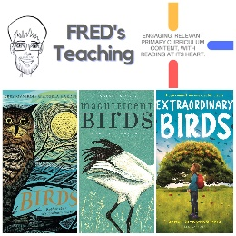 | 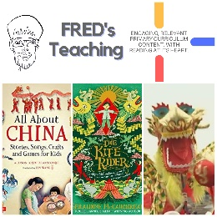 | 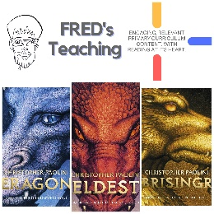 | 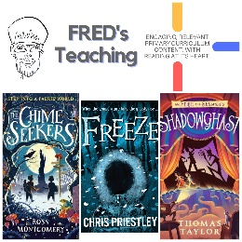 | 

