Week 1: 08/01/24 | Week 2: 15/01/24 | Week 3: 22/01/24 | Week 4: 29/01/24 | Week 5: 05/02/24
Theme: New Year Traditions | Theme: Chinese New Year | Theme: Awesome Series – Songs of Magic | Theme: National Story-telling Week is 30th Jan – 6th Feb | Theme: Children’s Mental Health Week is 5th – 11th Feb
Extracts:  - Every Month is a New Year (non-fiction).  - Scholastic: New Year Traditions Around the World (non-fiction).  - Ring Out, Wild Bells (poem). | Extracts:  - All About China (non-fiction).  - China Through Time (non-fiction).  - Legend of Nian: Lunar New Year for Kids (YouTube video). | Extracts:  - A Darkness of Dragons.  - A Vanishing of Griffins.  - A Thunder of Monsters. | Extracts:  - The World Book (non-fiction).  - When Fishes Flew.  - The Hideaway. | Extracts:  - The Invisible (full PB).  - Roar Like a Lion (non-fiction).  - The Girl With Space in Her Heart.
25 pieces of Tier 2 and Tier 3 vocabulary.  21 retrieval questions.  3 writing challenges. | 22 pieces of Tier 2 and Tier 3 vocabulary.  21 retrieval questions.  3 writing challenges. | 25 pieces of Tier 2 and Tier 3 vocabulary.  21 retrieval questions.  3 writing challenges. | 22 pieces of Tier 2 and Tier 3 vocabulary.  21 retrieval questions.  3 writing challenges. | 25 pieces of Tier 2 and Tier 3 vocabulary.  21 retrieval questions.  3 writing challenges.
10 EXTENSION questions to stretch learners. | 17 EXTENSION questions to stretch learners. | 16 EXTENSION questions to stretch learners. | 17 EXTENSION questions to stretch learners. | 9 EXTENSION questions to stretch learners.
Content Domains covered: 2a, 2b, 2c, 2d, 2e, 2f, 2g, 2h | Content Domains covered: 2a, 2b, 2c, 2d, 2e, 2f, 2g, 2h | Content Domains covered: 2a, 2b, 2c, 2d, 2e, 2f, 2g, 2h | Content Domains covered: 2a, 2b, 2c, 2d, 2e, 2f, 2g, 2h | Content Domains covered: 2a, 2b, 2c, 2d, 2e, 2f, 2g, 2h
Search: UKS2 New Year Reading  DIRECT LINK | Search: UKS2 Chinese New Year v1  DIRECT LINK | Search: UKS2 Songs of Magic  DIRECT LINK | Search: UKS2 Best Books of 2021 v1  DIRECT LINK | Search: The Invisible  DIRECT LINK
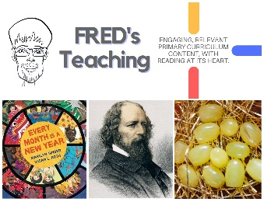 | 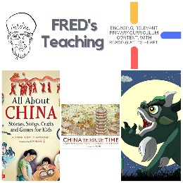 | 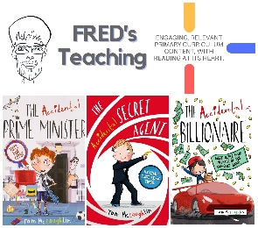 | 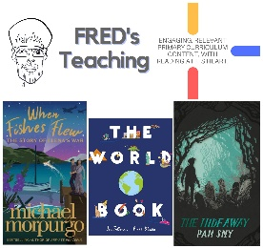 | 

