Week 1: 08/01/24 | Week 2: 15/01/24 | Week 3: 22/01/24 | Week 4: 29/01/24 | Week 5: 05/02/24
Theme: New Year Traditions | Theme: Chinese New Year | Theme: Awesome Series – The Accidentals | Theme: National Story-telling Week is 30th Jan – 6th Feb | Theme: Children’s Mental Health Week is 5th – 11th Feb
Extracts:  - Freedom Soup (Full PB).  - Every Month is a New Year (non-fiction).  - Newsround Article: Five New Year Traditions (non-fiction). | Extracts:  - cBeebies Chinese New Year Zodiac Story (YouTube video).  - The Great Race (PB).  - National Geographic Kids China (non-fiction). | Extracts:  - The Accidental Prime Minister.  - The Accidental Secret Agent.  - The Accidental Billionaire. | Extracts:  - Count.  - Star Cat (Graphic Novel).  - Freddy and the New Kid. | Extracts:  - Ruby’s Worry (full PB).  - Black Dog.  - Inside Out (Movie trailer #2).
22 pieces of Tier 2 and Tier 3 vocabulary.  18 retrieval questions. | 22 pieces of Tier 2 and Tier 3 vocabulary.  18 retrieval questions. | 21 pieces of Tier 2 and Tier 3 vocabulary.  18 retrieval questions. | 19 pieces of Tier 2 and Tier 3 vocabulary.  18 retrieval questions. | 19 pieces of Tier 2 and Tier 3 vocabulary.  18 retrieval questions.
5 EXTENSION questions to stretch learners. | 12 EXTENSION questions to stretch learners. | 10 EXTENSION questions to stretch learners. | 10 EXTENSION questions to stretch learners. | 7 EXTENSION questions to stretch learners.
Content Domains covered: 2a, 2b, 2c, 2d, 2e, 2f, 2g, 2h | Content Domains covered: 2a, 2b, 2c, 2d, 2e, 2f, 2g, 2h | Content Domains covered: 2a, 2b, 2c, 2d, 2e, 2f, 2g, 2h | Content Domains covered: 2a, 2b, 2c, 2d, 2e, 2f, 2g, 2h | Content Domains covered: 2a, 2b, 2c, 2d, 2e, 2f, 2g, 2h
Search: LKS2 New Year Planning  DIRECT LINK | Search: LKS2 Chinese New Year v1  DIRECT LINK | Search: LKS2 The Accidentals  DIRECT LINK | Search: LKS2 Best Books of 2021 v1  DIRECT LINK | Search: Ruby’s Worry  DIRECT LINK
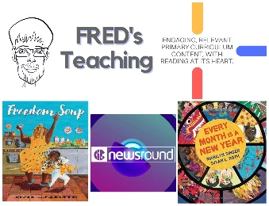 | 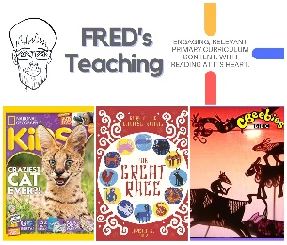 | 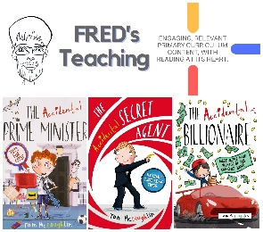 | 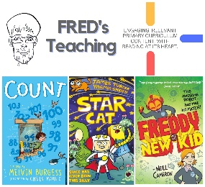 | 

