Week 1: 08/01/24 | Week 2: 15/01/24 | Week 3: 22/01/24 | Week 4: 29/01/24 | Week 5: 05/02/24
Theme: Birds | Theme: Chinese New Year | Theme: Awesome Series – Dick Kerr Girls Football | Theme: National Story-telling Week is 30th Jan – 6th Feb | Theme: Children’s Mental Health Week is 5th – 11th Feb
Extracts:  - Lets Look for Garden Birds (non-fiction).  - RSPB Nature Guide Birds (non-fiction).  - The Extraordinary World of Birds (non-fiction). | Extracts:  - All About China (non-fiction).  - The Firework-Maker’s Daughter.  - Scholastic Lunar New Year for Kids (YouTube video). | Extracts:  - Dick Kerr Girls: Kicking Off.  - Dick Kerr Girls: The Perfect Shot.  - Newsround Article: Lionesses Win Euro 2022 (non-fiction). | Extracts:  - Cookie and the Most Mysterious Mystery in the World.  - Mason Mooney Paranormal Investigator (Graphic Novel).  - The Ordnance Survey Kids’ Adventure Book (non-fiction). | Extracts:  - Ravi’s Roar (full PB).  - What to Do When You Worry Too Much (non-fiction).  - Charlie Changes into a Chicken.
21 pieces of Tier 2 and Tier 3 vocabulary.  18 retrieval questions. | 18 pieces of Tier 2 and Tier 3 vocabulary.  18 retrieval questions. | 20 pieces of Tier 2 and Tier 3 vocabulary.  18 retrieval questions. | 19 pieces of Tier 2 and Tier 3 vocabulary.  18 retrieval questions. | 20 pieces of Tier 2 and Tier 3 vocabulary.  18 retrieval questions.
6 EXTENSION questions to stretch learners. | 12 EXTENSION questions to stretch learners. | 12 EXTENSION questions to stretch learners. | 9 EXTENSION questions to stretch learners. | 6 EXTENSION questions to stretch learners.
Content Domains covered: 2a, 2b, 2c, 2d, 2e, 2f, 2g, 2h | Content Domains covered: 2a, 2b, 2c, 2d, 2e, 2f, 2g, 2h | Content Domains covered: 2a, 2b, 2c, 2d, 2e, 2f, 2g, 2h | Content Domains covered: 2a, 2b, 2c, 2d, 2e, 2f, 2g, 2h | Content Domains covered: 2a, 2b, 2c, 2d, 2e, 2f, 2g, 2h
Search: LKS2 Birds Topic  DIRECT LINK | Search: LKS2 Chinese New Year v2  DIRECT LINK | Search: LKS2 Dick Kerr Girls  DIRECT LINK | Search: LKS2 Best Books of 2021 v2  DIRECT LINK | Search: Ravi’s Roar  DIRECT LINK
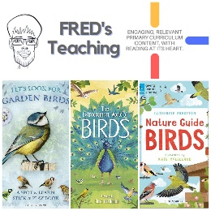 |  | 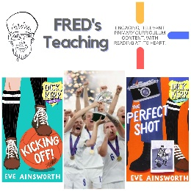 | 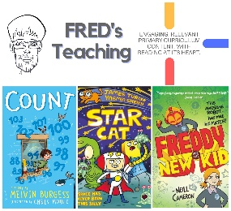 | 

