Week 1: 30/10/23 | Week 2: 06/11/23 | Week 3: 13/11/23 | Week 4: 20/11/23 | Week 5: 27/11/23 | Week 6: 04/12/23 | Week 7: 11/12/23 | Week 8: 18/12/23
Theme: Halloween. | Theme: Bonfire Night. | Theme: Remembrance. | Theme: Awesome Men – 19th November is International Men’s Day. | Theme: Best Books of 2023 | Theme: Time Travel – 8th December is Pretend to be a Time Traveller Day. | Theme: Christmas. | Theme: Christmas
Extracts:  - Goosebumps Horrorland: Revenge of the Living Dummy.  - Locked out Lily.  - The Haunting of Aveline Jones. | Extracts:  - History of Bonfire Night Article (NF).  - Fire Spell.  - Fire Witch. | Extracts:  - Once.  - The Emergency Zoo.  - The Machine Gunners. | Extracts:  - Charles Darwin Day Newsround Article (NF).  - Charles Darwin and the Beagle Adventure.  - On the Origin of Species (NF). | Extracts:  - Tyger.  - Stolen History (NF).  - Away With Words. | Extracts:  - The Time Machine.  - Time Travelling with a Hamster.  - The Reluctant Time Traveller. | Extracts:  - The Miracle on Ebenezer Street.  - A Christmas Carol.  - The Muppet’s Christmas Carol (movie trailer). | Extracts:  - Tinsel.  - The Christmas Carrolls.  - How the Grinch Stole Christmas (movie trailer).
22 pieces of Tier 2 and Tier 3 vocabulary.  21 retrieval questions.  3 writing challenges. | 24 pieces of Tier 2 and Tier 3 vocabulary.  21 retrieval questions.  3 writing challenges. | 24 pieces of Tier 2 and Tier 3 vocabulary.  21 retrieval questions.  3 writing challenges. | 22 pieces of Tier 2 and Tier 3 vocabulary.  21 retrieval questions.  3 writing challenges. | 23 pieces of Tier 2 and Tier 3 vocabulary.  21 retrieval questions.  3 writing challenges. | 25 pieces of Tier 2 and Tier 3 vocabulary.  21 retrieval questions.  3 writing challenges. | 23 pieces of Tier 2 and Tier 3 vocabulary.  21 retrieval questions.  3 writing challenges. | ?? pieces of Tier 2 and Tier 3 vocabulary.  ?? retrieval questions.  3 writing challenges.
15 EXTENSION questions to stretch learners. | 14 EXTENSION questions to stretch learners. | 15 EXTENSION questions to stretch learners. | 18 EXTENSION questions to stretch learners. | 18 EXTENSION questions to stretch learners. | 11 EXTENSION questions to stretch learners. | 15 EXTENSION questions to stretch learners. | ? EXTENSION questions to stretch learners.
Content Domains covered: 2a, 2b, 2c, 2d, 2e, 2f, 2g, 2h | Content Domains covered: 2a, 2b, 2c, 2d, 2e, 2f, 2g, 2h | Content Domains covered: 2a, 2b, 2c, 2d, 2e, 2f, 2g, 2h | Content Domains covered: 2a, 2b, 2c, 2d, 2e, 2f, 2g, 2h | Content Domains covered: 2a, 2b, 2c, 2d, 2e, 2f, 2g, 2h | Content Domains covered: 2a, 2b, 2c, 2d, 2e, 2f, 2g, 2h | Content Domains covered: 2a, 2b, 2c, 2d, 2e, 2f, 2g, 2h | Content Domains covered: 2a, 2b, 2c, 2d, 2e, 2f, 2g, 2h
Search: UKS2 – More Halloween WCR  DIRECT LINK | Search: UKS2 – More Bonfire Night WCR  DIRECT LINK | Search: UKS2 – Remembrance WCR: Once  DIRECT LINK | Search: UKS2 – Awesome Men: Sir Charles Darwin  DIRECT LINK | Search: UKS2 – Best Books of 2023  DIRECT LINK | Search: UKS2 – More Time-Travel Themed WCR  DIRECT LINK | Search: UKS2 – Christmas WCR: A Christmas Carol  DIRECT LINK | Search: UKS2 – Christmas WCR: Tinsel and How the Grinch Stole Christmas  DIRECT LINK
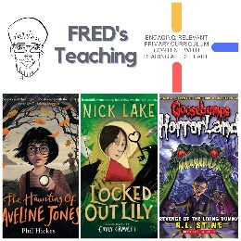 | 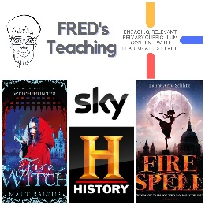 | 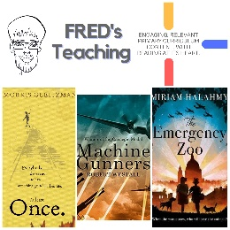 | 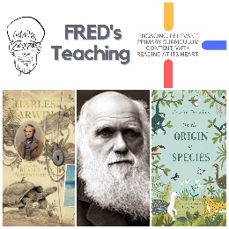 | 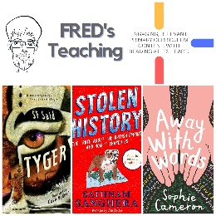 | 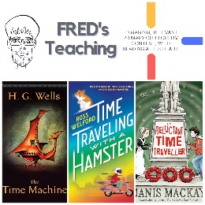 | 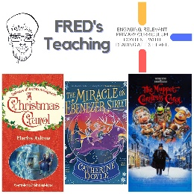 | 

