Week 1: 30/10/23 | Week 2: 06/11/23 | Week 3: 13/11/23 | Week 4: 20/11/23 | Week 5: 27/11/23 | Week 6: 04/12/23 | Week 7: 11/12/23 | Week 8: 18/12/23
Theme: Halloween. | Theme: Bonfire Night. | Theme: Remembrance. | Theme: Awesome Men – 19th November is International Men’s Day. | Theme: Best Books of 2023 | Theme: Time Travel – 8th December is Pretend to be a Time Traveller Day. | Theme: Christmas. | Theme: Christmas
Extracts:  - Newsround Article: Trick or Treating (NF).  - Horrid Henry’s Halloween Horrors.  - Monstacademy: The Halloween Parade. | Extracts:  - You Wouldn’t Want to be Guy Fawkes (NF).  - The Last Firefox.  - The Fire Thief. | Extracts:  - Daisy and the Unknown Warrior.  - Letters from the Lighthouse.  - Anne Frank’s Diary (Graphic Novel). | Extracts:  - Newsround article: Who Was Einstein (NF).  - Einstein’s Underpants.  - Max Einstein: The Genius Experiment. | Extracts:  - The Other Edie Trimmer.  - Loki: A Bad God’s Guide to Being Good.  - Little Badman and the Rise of the Punjabi Zombies. | Extracts:  - The Accidental Time Travel.  - Tom’s Midnight Garden.  - Harry Potter and the Goblet of Fire (film clip). | Extracts:  - How Winston Delivered Christmas.  - The Night I Met Father Christmas.  - Jingle all the Way (movie trailer). | Extracts:  - The Christmasaurus and the Winter Witch.  - The Christmasaurus and the Naughty List.  - Klaus (movie trailer).
119 pieces of Tier 2 and Tier 3 vocabulary.  18 retrieval questions. | 23 pieces of Tier 2 and Tier 3 vocabulary.  18 retrieval questions. | 21 pieces of Tier 2 and Tier 3 vocabulary.  18 retrieval questions. | 18 pieces of Tier 2 and Tier 3 vocabulary.  18 retrieval questions. | 20 pieces of Tier 2 and Tier 3 vocabulary.  18 retrieval questions. | 19 pieces of Tier 2 and Tier 3 vocabulary.  16 retrieval questions. | 22 pieces of Tier 2 and Tier 3 vocabulary.  18 retrieval questions. | 18 pieces of Tier 2 and Tier 3 vocabulary.  18 retrieval questions.
10 EXTENSION questions to stretch learners. | 12 EXTENSION questions to stretch learners. | 8 EXTENSION questions to stretch learners. | 7 EXTENSION questions to stretch learners. | 12 EXTENSION questions to stretch learners. | 9 EXTENSION questions to stretch learners. | 11 EXTENSION questions to stretch learners. | 12 EXTENSION questions to stretch learners.
Content Domains covered: 2a, 2b, 2c, 2d, 2e, 2f, 2g, 2h | Content Domains covered: 2a, 2b, 2c, 2d, 2e, 2f, 2g, 2h | Content Domains covered: 2a, 2b, 2c, 2d, 2e, 2f, 2g, 2h | Content Domains covered: 2a, 2b, 2c, 2d, 2e, 2f, 2g, 2h | Content Domains covered: 2a, 2b, 2c, 2d, 2e, 2f, 2g, 2h | Content Domains covered: 2a, 2b, 2c, 2d, 2e, 2f, 2g, 2h | Content Domains covered: 2a, 2b, 2c, 2d, 2e, 2f, 2g, 2h | Content Domains covered: 2a, 2b, 2c, 2d, 2e, 2f, 2g, 2h
Search: LKS2 – More Halloween WCR  DIRECT LINK | Search: LKS2 – More Bonfire Night WCR  DIRECT LINK | Search: LKS2 – Remembrance WCR: Anne Frank’s Diary  DIRECT LINK | Search: LKS2 – Awesome Men: Einstein  DIRECT LINK | Search: LKS2 – Best Books of 2023  DIRECT LINK | Search: LKS2 – More Time-Travel Themed WCR  DIRECT LINK | Search: LKS2 – Christmas WCR: The Night I Met Father Christmas  DIRECT LINK | Search: LKS2 – Christmas WCR: More Christmasaurus and Klaus  DIRECT LINK
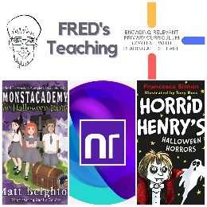 | 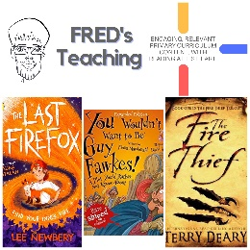 | 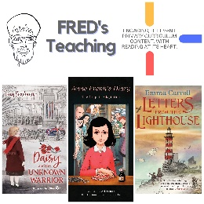 | 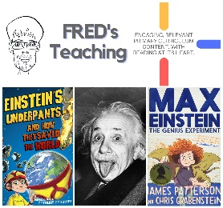 | 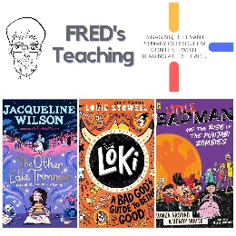 | 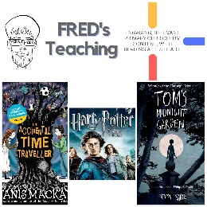 | 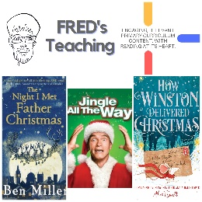 | 

