Week 1: 30/10/23 | Week 2: 06/11/23 | Week 3: 13/11/23 | Week 4: 20/11/23 | Week 5: 27/11/23 | Week 6: 04/12/23 | Week 7: 11/12/23 | Week 8: 18/12/23
Theme: Halloween. | Theme: Bonfire Night. | Theme: Remembrance. | Theme: Awesome Men – 19th November is International Men’s Day. | Theme: Best Books of 2023 | Theme: Time Travel – 8th December is Pretend to be a Time Traveller Day. | Theme: Christmas. | Theme: Christmas
Extracts:  - A Dark, Dark Tale (PB).  - Room 13.  - Whitby Travel Guide (NF). | Extracts:  - Wildwitch: Wildfire.  - Newsround Article: Bonfire Night Fireworks (NF).  - It’s Bonfire Night (poem). | Extracts:  - 50 Things You Should Know About WW2 (NF).  - Wait for Me (poem).  - Newsround Article: Heroic WW2 Dog (NF). | Extracts:  - Little People, Big Dreams: David Attenborough (PB).  - A Life on Our Planet (NF).  Newsround Article: Young People (NF). | Extracts:  - Jodie.  - Nic Blake and the Remarkables: The Manifestor Prophecy.  - Circus Maximus: Rider of the Storm. | Extracts:  - A Chase in Time.  - My Cousin is a Time Traveller.  - A Wrinkle in Time. | Extracts:  - A Boy Called Christmas.  - Mistletoe and Murder.  - Home Alone (movie trailer). | Extracts:  - Virtually Christmas.  - Diary of a Christmas Elf.  - Jingle Jangle (movie trailer).
18 pieces of Tier 2 and Tier 3 vocabulary.  21 retrieval questions.  3 writing challenges. | 18 pieces of Tier 2 and Tier 3 vocabulary.  21 retrieval questions.  3 writing challenges. | 24 pieces of Tier 2 and Tier 3 vocabulary.  21 retrieval questions.  3 writing challenges. | 24 pieces of Tier 2 and Tier 3 vocabulary.  21 retrieval questions.  3 writing challenges. | 21 pieces of Tier 2 and Tier 3 vocabulary.  21 retrieval questions.  3 writing challenges. | 24 pieces of Tier 2 and Tier 3 vocabulary.  21 retrieval questions.  3 writing challenges. | 22 pieces of Tier 2 and Tier 3 vocabulary.  21 retrieval questions.  3 writing challenges. | 21 pieces of Tier 2 and Tier 3 vocabulary.  21 retrieval questions.  3 writing challenges.
12 EXTENSION questions to stretch learners. | 17 EXTENSION questions to stretch learners. | 18 EXTENSION questions to stretch learners. | 15 EXTENSION questions to stretch learners. | 18 EXTENSION questions to stretch learners. | 12 EXTENSION questions to stretch learners. | 15 EXTENSION questions to stretch learners. | 18 EXTENSION questions to stretch learners.
Content Domains covered: 2a, 2b, 2c, 2d, 2e, 2f, 2g, 2h | Content Domains covered: 2a, 2b, 2c, 2d, 2e, 2f, 2g, 2h | Content Domains covered: 2a, 2b, 2c, 2d, 2e, 2f, 2g, 2h | Content Domains covered: 2a, 2b, 2c, 2d, 2e, 2f, 2g, 2h | Content Domains covered: 2a, 2b, 2c, 2d, 2e, 2f, 2g, 2h | Content Domains covered: 2a, 2b, 2c, 2d, 2e, 2f, 2g, 2h | Content Domains covered: 2a, 2b, 2c, 2d, 2e, 2f, 2g, 2h | Content Domains covered: 2a, 2b, 2c, 2d, 2e, 2f, 2g, 2h
Search: UKS2 – Halloween Week Planning  DIRECT LINK | Search: UKS2 – Bonfire Night WCR  DIRECT LINK | Search: UKS2 – Remembrance WCR: 5O Things and Wait For Me  DIRECT LINK | Search: UKS2 – Awesome Men: Sir David Attenborough  DIRECT LINK | Search: UKS2 – More Best Books of 2023  DIRECT LINK | Search: UKS2 – Time-Travel Themed WCR  DIRECT LINK | Search: UKS2 – Christmas WCR: A Boy Called Christmas  DIRECT LINK | Search: UKS2 – Christmas WCR: Virtually Christmas and Jingle Jangle  DIRECT LINK
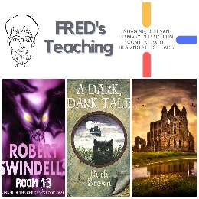 | 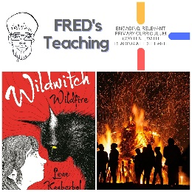 | 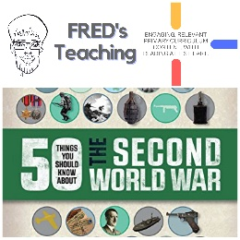 | 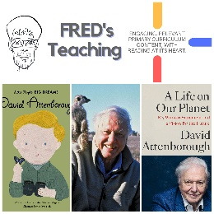 | 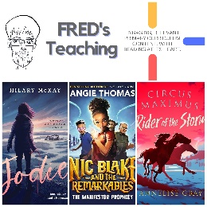 | 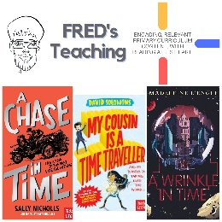 | 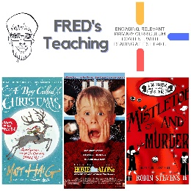 | 

