End of Year Report: St John the Baptist Catholic Primary School
Reading
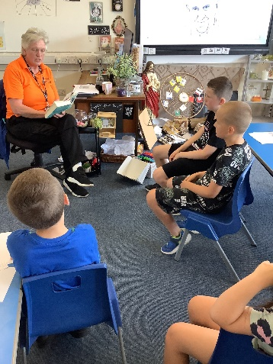
Throughout this year, we have remained steadfast in our commitment to promote a culture of reading within our school community. By offering children a plethora of reading opportunities, implementing Fred's Teaching, emphasising vocabulary development, and utilizing data analysis from Accelerated Reader, we have achieved remarkable progress in our reading initiatives. Additionally, we have made our library a calm and nurturing environment, where children can read silently, and we have strengthened connections between our Class Read and English units. These efforts have contributed significantly to the growth and success of our reading curriculum.

Championing Reading:
Reading continues to be at the heart of our school's ethos. We have consistently championed reading by providing children with numerous opportunities to explore the world of literature. Regular class visits to the school library, engaging book discussions, and various reading challenges have cultivated a passion for reading among our students.
Fred's Teaching Approach:
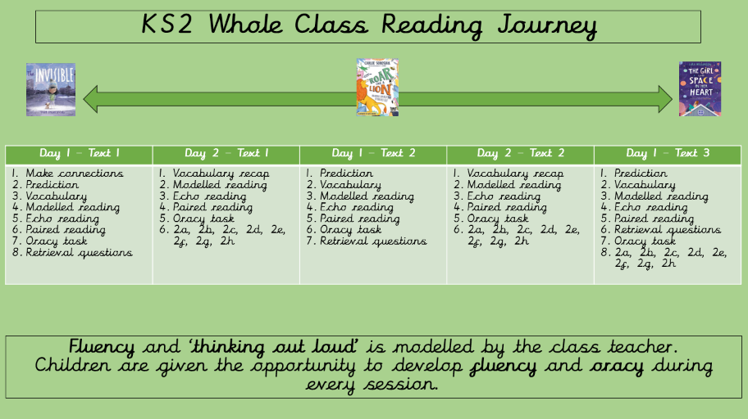
This year, we introduced Fred's Teaching, a whole class reading approach that has proven to be highly effective. By engaging students collectively, we have observed accelerated progress in reading levels across Key Stage 2 (KS2). The structured sessions have provided our students with a deeper understanding of texts and improved their reading comprehension skills. As a result, our school has witnessed a noticeable increase in SATS results, demonstrating the positive impact of this teaching method.
Vocabulary Development:
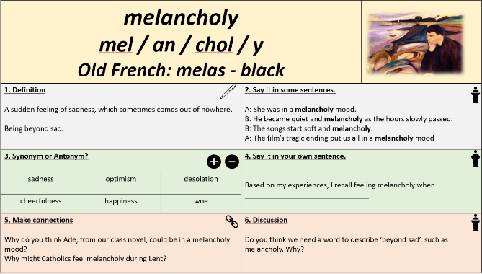
After reading research from the EEF in regard to vocabulary instruction, we have placed a strong emphasis on vocabulary development. In every lesson, teachers have explicitly taught new words, exploring their etymology, origins, and meanings. This approach has empowered students to enrich their vocabulary and develop a deeper understanding of language. We have also given ample opportunities for oracy practice, allowing children to play with words, engage in discussions, and express themselves confidently.

Fred's Fluent in 5 Interventions:
In our commitment to supporting every student's reading journey, we have implemented Fred's Fluent in 5 intervention program. This targeted initiative has provided additional support to children who needed extra help in their reading development. The small-group sessions have resulted in significant progress for those involved, boosting their reading fluency and comprehension.
World Book Day and Pyjamarama Celebration:
As part of our effort to foster a love for literature, we celebrated World Book Day with enthusiasm. The entire school came together to celebrate the joy of reading and the wonder of books. Students and staff dressed up as their favorite book characters, and we organized various engaging activities, such as author visits, storytelling sessions, and book-themed competitions. The day was a resounding success, leaving lasting memories and inspiring our students to explore new books.

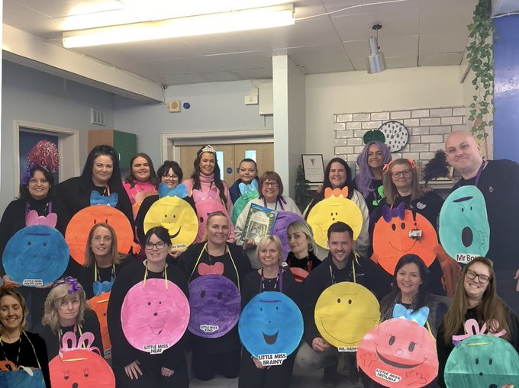

Expanding Reading Resources:
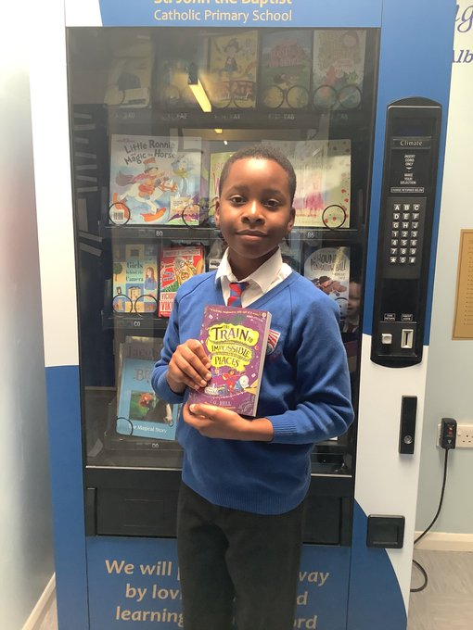
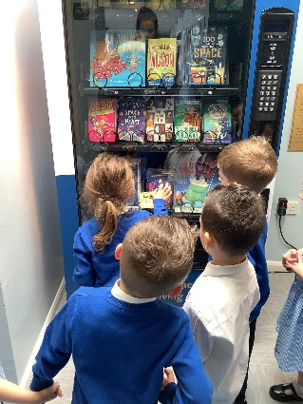
To further enrich our students' reading experiences, our school invested in a vast collection of books. A team of dedicated staff members visited Peter's Book Store and purchased books worth £2000. These books have supplemented our existing PKC curriculum, providing children with access to a diverse range of engaging texts. Additionally, they have enriched our Accelerated Reader program, encouraging students to read widely and expand their literary horizons.
Continued Success of the Book Vending Machine:
The Book Vending Machine has been a tremendous hit among our students, motivating them to achieve their reading goals. Students who earn 20 points through the Accelerated Reader program are rewarded with the opportunity to choose books from the vending machine. This innovative approach has encouraged healthy reading habits and has been a testament to our commitment to making reading enjoyable for all.
Creating a Calm and Nurturing Library Environment:
Our school library has been transformed into a calm and nurturing space, specifically designed to encourage students to immerse themselves in the joy of reading. The library is adorned with cosy reading corners, comfortable seating arrangements, and soft lighting, creating a welcoming atmosphere for students to relax and delve into their favourite books. Our dedicated librarian ensures that the library remains an oasis of tranquillity, promoting a sense of serenity that enables children to read silently and absorb themselves in the world of literature.
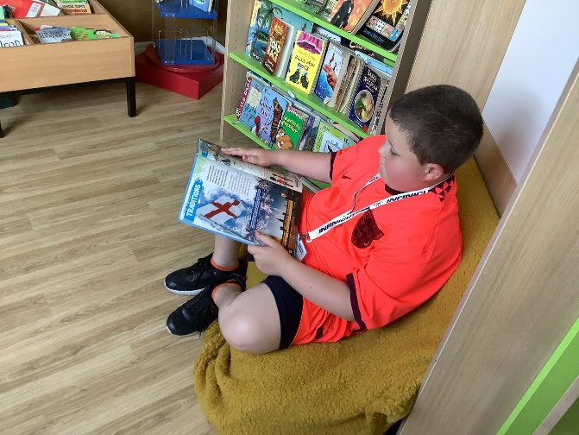
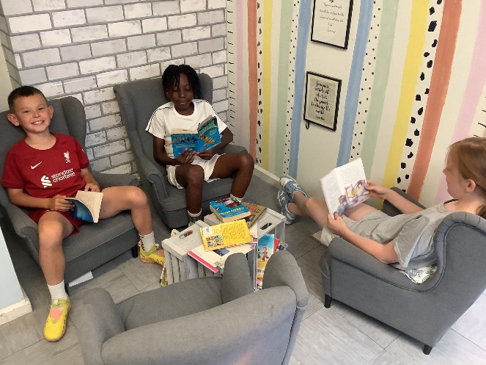

Utilizing Rigorous Data Analysis from Accelerated Reader:
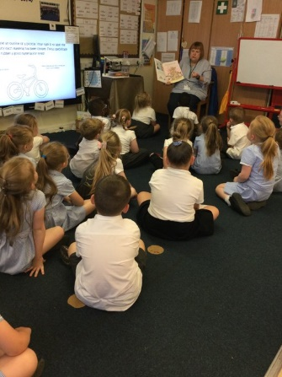
Our commitment to data-driven instruction has been instrumental in identifying areas for development in reading. Through the Accelerated Reader program, students take book quizzes after completing their reading, providing valuable insights into their comprehension and literacy levels. The rigorous data analysis from these quizzes, combined with Star Reading assessments, offers a comprehensive view of each student's reading progress. This data-driven approach allows our teachers to tailor their instruction to meet individual learning needs effectively.
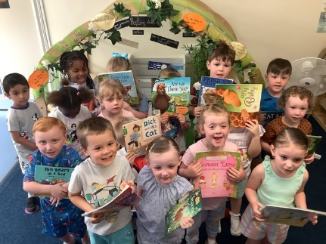
Sharing Books in Key Stage Assemblies:
Promoting reading is a collaborative effort, and our Key Stage assemblies have become a platform to celebrate and share the joy of books. During these assemblies, students and teachers alike share their favourite reads, recommending books they found inspiring or enjoyable. By doing so, we create a vibrant reading community, where students are encouraged to explore a diverse array of literature and broaden their literary tastes.
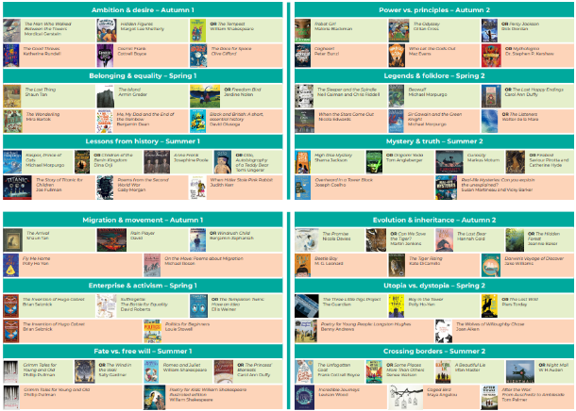
Making Strong Connections Between Class Read and English Units:
In our primary school reading curriculum, we have recognized the immense value of making strong connections between the Class Read and our English units. This intentional integration serves as a powerful tool to enhance the overall reading experience for our students. By selecting class reads that align with the themes, topics, or historical periods covered in our English units, we provide children with a rich and interconnected learning journey.

Contextual Understanding:
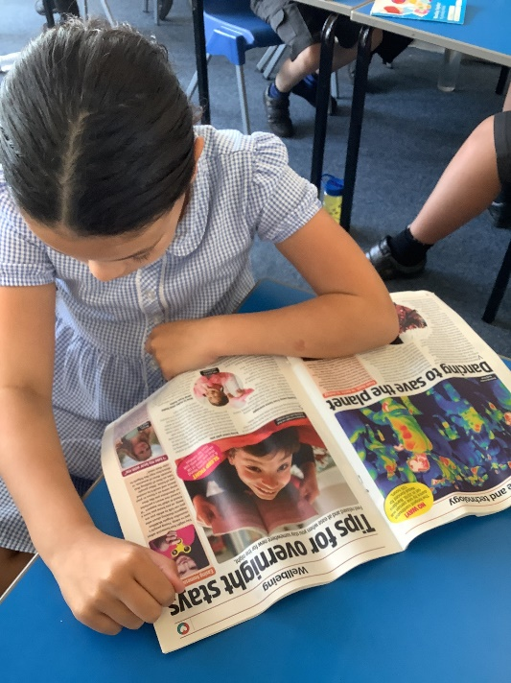
The Class Read, which is read aloud to the children by their teacher, serves as a gateway to a world of literature that complements the content covered in our English units. By carefully selecting books that share similar themes, settings, or character dynamics, we enhance the students' contextual understanding of the English unit topics. For example, if our English unit focuses on historical fiction set during World War II, the chosen Class Read might be a book that explores a child's experiences during that period. This allows students to immerse themselves in the historical context and empathize with characters, providing a deeper appreciation of the time and setting.
Background Information:
Through the Class Read, students are exposed to a variety of pieces of information that enrich their background knowledge. For instance, if our English unit revolves around myths and legends, the Class Read might be an anthology of ancient stories from different cultures. This exposure to diverse myths provides students with a broader understanding of the subject and helps them draw connections between different cultures and their respective mythologies.
Cognitive Development:
The strong connections between Class Read and English units offer cognitive benefits to our students. Engaging with literature that complements the English unit content helps develop critical thinking skills and encourages students to draw comparisons, contrasts, and parallels between texts. This higher-level thinking promotes a more profound understanding of both the Class Read and the English unit's learning objectives.
Emotional Connection:
The alignment of the Class Read and English units fosters an emotional connection with the material. As students encounter familiar themes, characters, or settings in different contexts, they develop a sense of familiarity and comfort with the content. This emotional connection enhances their engagement and enthusiasm for learning, making the reading experience more meaningful and enjoyable.
Literary Appreciation:
The integration of the Class Read with our English units also promotes literary appreciation among our students. Exposing them to a wide range of books, genres, and writing styles helps them develop a discerning taste for literature. As they draw connections between different texts, they begin to recognise patterns and motifs across various works, deepening their appreciation for the art of storytelling.

Looking Ahead
As we move forward, we are excited to further enhance our primary school reading curriculum by introducing the SoundsWrite approach across the whole school. The SoundsWrite approach is a structured phonics program that has shown remarkable success in developing children's reading and spelling skills. To ensure its successful implementation, we will provide comprehensive staff Continuous Professional Development sessions, equipping our teachers with the necessary knowledge and skills to effectively deliver the program. Through curriculum design, we will seamlessly integrate the SoundsWrite approach into our reading instruction, fostering a strong foundation for reading and spelling proficiency across all year groups.
Disciplinary Reading and PKC Unit:
In our pursuit of fostering well-rounded readers, we recognize the importance of disciplinary reading. As we continue to develop our PKC (Personal, Knowledge, and Culture) unit, we will provide children with even more opportunities to read for a variety of reasons. This includes exploring non-fiction texts, scientific articles, historical documents, and other subject-specific materials relevant to their learning. By integrating disciplinary reading into our curriculum, we aim to empower our students to read critically, think analytically, and engage deeply with subject-specific content, furthering their intellectual growth.
Developing Vocabulary Teaching and Oracy Engagement:
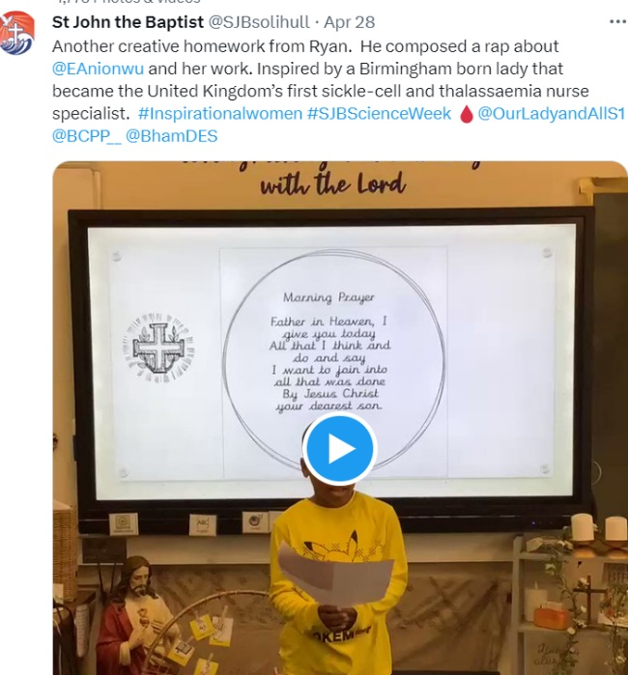
Addressing the vocabulary deficit in our students remains a top priority. To continue developing our vocabulary teaching, we will implement research-based strategies to explicitly teach and reinforce new words across all subjects. Moreover, we will continue exploring etymology, origins, and meanings, empowering students to develop a strong command of language.
To tackle the issue of oracy deprivation, we will further elevate our oracy engagement levels. We will provide ample opportunities for students to participate in discussions, debates, and presentations, encouraging them to articulate their thoughts confidently and express themselves effectively. Through this focus on oracy, we aim to strengthen communication skills, boost self-assurance, and enhance overall language development.

