Week 1: 4/9/23 | Week 2: 11/9/23 | Week 3: 18/9/23 | Week 4: 25/9/23 | Week 5: 2/10/23 | Week 6: 9/10/23 | Week 7: 16/10/23 | Week 8: 23/10/23
Theme: Michael Morpurgo | Theme: Roald Dahl – 13th September is Dahl Day! | Theme: Deaf Awareness – 19th-25th September is International Week of Deaf People. | Theme: Around the World: Egypt | Theme: Poetry – 5th October is National Poetry Day. | Theme: Black History Month – Katherine Johnson. | Theme: Black History Month – Black Britons and Windrush. | Theme: Black History Month – Young, Gifted and Black.
Extracts:  - Listen to the Moon by Michael Morpurgo.  - Half a Man by Michael Morpurgo.  - I Believe in Unicorns by Michael Morpurgo. | Extracts:  - The Witches.  - Charlie and the Chocolate Factory.  - The Gloriumptious Worlds of Roald Dahl (NF). | Extracts:  - Wonder Struck.  - Max and the Millions.  - Newsround article ‘Deaf Awareness Week’ (NF). | Extracts:  - Immortal Egypt (TV Clip).  - Egyptology by Dugald Steer (NF).  - Secrets of a Sun King by Emma Carroll. | Extracts:  - What You Need to be Warm by Neil Gaiman.  - The British by Benjamin Zephaniah.  - Adventures of Isabel by Ogden Nash. | Extracts:  - The Extraordinary Life of Katherine Johnson (NF).  - Hidden Figures (Young Readers Edition).  - NASA Biography of Katherine Johnson (NF). | Extracts:  - Black and British (NF).  - Windrush Generation BBC News article (NF).  - Windrush Child. | Extracts:  - 3 extracts from the book Young, Gifted and Black (NF).  - Duvernay and Coleman.  - Adichie and Freeman.  - Carver and Blackman.
24 pieces of Tier 2 and Tier 3 vocabulary.  21 retrieval questions.  3 writing challenges. | 22 pieces of Tier 2 and Tier 3 vocabulary.  21 retrieval questions.  3 writing challenges. | 22 pieces of Tier 2 and Tier 3 vocabulary.  21 retrieval questions.  3 writing challenges. | 22 pieces of Tier 2 and Tier 3 vocabulary.  21 retrieval questions.  3 writing challenges. | 25 pieces of Tier 2 and Tier 3 vocabulary.  21 retrieval questions.  3 writing challenges. | 22 pieces of Tier 2 and Tier 3 vocabulary.  21 retrieval questions.  3 writing challenges. | 22 pieces of Tier 2 and Tier 3 vocabulary.  21 retrieval questions.  3 writing challenges. | 24 pieces of Tier 2 and Tier 3 vocabulary.  21 retrieval questions.  3 writing challenges.
13 EXTENSION questions to stretch learners. | 16 EXTENSION questions to stretch learners. | 15 EXTENSION questions to stretch learners. | 15 EXTENSION questions to stretch learners. | 7 EXTENSION questions to stretch learners. | 9 EXTENSION questions to stretch learners. | 11 EXTENSION questions to stretch learners. | 17 EXTENSION questions to stretch learners.
Content Domains covered: 2a, 2b, 2c, 2d, 2e, 2f, 2g, 2h | Content Domains covered: 2a, 2b, 2c, 2d, 2e, 2f, 2g, 2h | Content Domains covered: 2a, 2b, 2c, 2d, 2e, 2f, 2g, 2h | Content Domains covered: 2a, 2b, 2c, 2d, 2e, 2f, 2g, 2h | Content Domains covered: 2a, 2b, 2c, 2d, 2e, 2f, 2g, 2h | Content Domains covered: 2a, 2b, 2c, 2d, 2e, 2f, 2g, 2h | Content Domains covered: 2a, 2b, 2c, 2d, 2e, 2f, 2g, 2h | Content Domains covered: 2a, 2b, 2c, 2d, 2e, 2f, 2g, 2h
Search: UKS2 Favourite Authors Michael Morpurgo | Search: UKS2 Roald Dahl Week 1 | Search: UKS2 Deaf Awareness 1 | Search: Around the World: Egypt | Search: UKS2 Poetry Week: Male Poets | Search: UKS2 Black History Month: Katherine Johnson | Search: UKS2 Black History Month: Black Britons and Windrush | Search: UKS2 Black History Month: Young, Gifted and Black
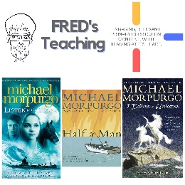 | 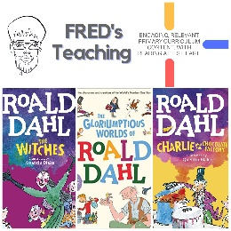 | 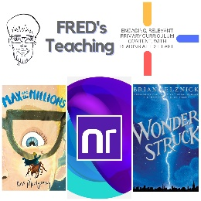 | 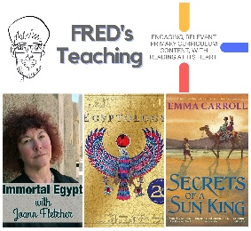 | 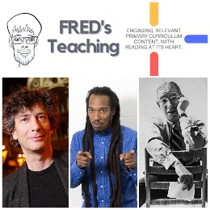 | 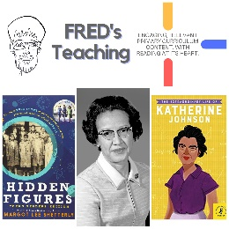 | 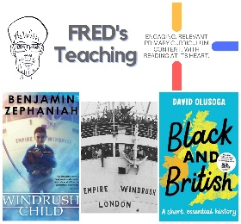 | 

