Week 1: 4/9/23 | Week 2: 11/9/23 | Week 3: 18/9/23 | Week 4: 25/9/23 | Week 5: 2/10/23 | Week 6: 9/10/23 | Week 7: 16/10/23 | Week 8: 23/10/23
Theme: Here We Are. | Theme: Roald Dahl – 13th September is Dahl Day! | Theme: Deaf Awareness – 19th-25th September is International Week of Deaf People. | Theme: Around the World: The Amazon | Theme: Poetry – 5th October is National Poetry Day. | Theme: Black History Month – Rosa Parks and The Bristol Bus Boycotts. | Theme: Black History Month – The ‘Voices’ Series. | Theme: Black History Month – Little Leaders Series.
Extracts:  - Here We Are (full PB).  - Easy Science for Kids article ‘Population Growth’ (NF). | Extracts:  - The Magic Finger.  - The Twits.  - The Gloriumptious World of Roald Dahl (NF). | Extracts:  - Newsround article ‘International Day of Sign Language’ (NF).  - Echo Come Home.  - Harriet Versus the Galaxy. | Extracts:  - Slowly, Slowly, Slowly said the Sloth by Eric Carle (full PB).  - Survivors by David Long (NF).  - The Explorer by Katherine Rundell. | Extracts:  - High Waving Heather by Emily Bronte.  - Zennor by Anne Ridler.  - Midday and Afternoon by Amy Lowell. | Extracts:  - Little People, Big Dreams: Rosa Parks (NF).  - Rosa Parks BBC Bitesize article (NF).  - The Story of the Bristol Bus Boycotts (YouTube video). | Extracts:  - Now or Never.  - Diver’s Daughter.  - A Victorian Story. | Extracts:  - Little Leaders: Bold Women in Black History (NF).  - Little Leaders: Exceptional Men in Black History (NF).
18 pieces of Tier 2 and Tier 3 vocabulary.  18 retrieval questions. | 20 pieces of Tier 2 and Tier 3 vocabulary.  18 retrieval questions. | 18 pieces of Tier 2 and Tier 3 vocabulary.  18 retrieval questions. | 17 pieces of Tier 2 and Tier 3 vocabulary (plus a challenge).  18 retrieval questions. | 20 pieces of Tier 2 and Tier 3 vocabulary.  18 retrieval questions. | 23 pieces of Tier 2 and Tier 3 vocabulary.  18 retrieval questions. | 18 pieces of Tier 2 and Tier 3 vocabulary.  18 retrieval questions. | 20 pieces of Tier 2 and Tier 3 vocabulary.  18 retrieval questions.
12 EXTENSION questions to stretch learners. | 9 EXTENSION questions to stretch learners. | 8 EXTENSION questions to stretch learners. | 8 EXTENSION questions to stretch learners. | 2 EXTENSION questions to stretch learners. | 6 EXTENSION questions to stretch learners. | 9 EXTENSION questions to stretch learners. | 11 EXTENSION questions to stretch learners.
Content Domains covered: 2a, 2b, 2c, 2d, 2e, 2f, 2g, 2h | Content Domains covered: 2a, 2b, 2c, 2d, 2e, 2f, 2g, 2h | Content Domains covered: 2a, 2b, 2c, 2d, 2e, 2f, 2g, 2h | Content Domains covered: 2a, 2b, 2c, 2d, 2e, 2f, 2g, 2h | Content Domains covered: 2a, 2b, 2c, 2d, 2e, 2f, 2g, 2h | Content Domains covered: 2a, 2b, 2c, 2d, 2e, 2f, 2g, 2h | Content Domains covered: 2a, 2b, 2c, 2d, 2e, 2f, 2g, 2h | Content Domains covered: 2a, 2b, 2c, 2d, 2e, 2f, 2g, 2h
Search: LKS2 Here We Are | Search: LKS2 Roald Dahl Week 2 | Search: LKS2 Deaf Awareness 2 | Search: Around the World: The Amazon | Search: LKS2 Poetry Week: Female Poets | Search: LKS2 Black History Month: Rosa Parks | Search: LKS2 Black History Month: The Voices Series | Search: LKS2 Black History Month: Little Leaders Series
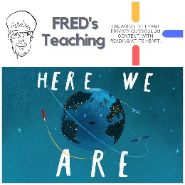 | 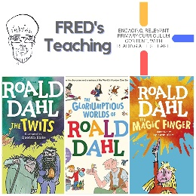 | 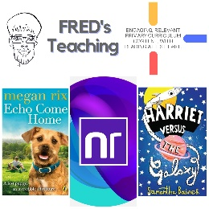 | 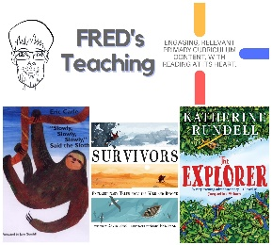 | 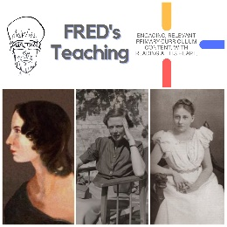 | 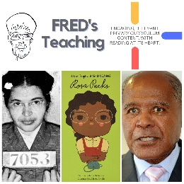 | 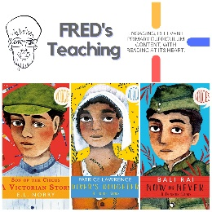 | 

