Week 1: 4/9/23 | Week 2: 11/9/23 | Week 3: 18/9/23 | Week 4: 25/9/23 | Week 5: 2/10/23 | Week 6: 9/10/23 | Week 7: 16/10/23 | Week 8: 23/10/23
Theme: Michael Morpurgo | Theme: Roald Dahl – 13th September is Dahl Day! | Theme: Deaf Awareness – 19th-25th September is International Week of Deaf People. | Theme: Around the World: The Himalayas | Theme: Poetry – 5th October is National Poetry Day. | Theme: Black History Month – Female Figures. | Theme: Black History Month – Space Scientists | Theme: Black History Month - Windrush
Extracts:  - My Father is a Polar Bear by Michael Morpurgo.  - Snug by Michael Morpurgo.  - Little Manfred by Michael Morpurgo. | Extracts:  - George’s Marvellous Medicine.  - James and the Giant Peach.  - The Gloriumptious World of Roald Dahl (NF). | Extracts:  - El Deafo (TV Show Trailer on YouTube).  - El Deafo.  - Tomorrow (song featured in El Deafo). | Extracts:  - The Abominables by Eva Ibbotson.  - Everest: The Remarkable Story by Alexandra Stewart (NF).  - Popcorn-eating Squirrels go Nuts on Everest by Matt Dickinson. | Extracts:  - Chocolate Cake by Michael Rosen.  - Walking With My Iguana by Brian Moses.  - The Porcupine by Roald Dahl. | Extracts:  - Fantastically Great Women who Worked Wonders (NF).  - Fantastically Great Women who Made History (NF).  - Little Leaders: Bold Women in Black History (NF). | Extracts:  - Mae Among the Stars (NF).  - Work it Girl: Mae Jemison (NF).  - Inspiring Scientists: Maddie Aderin-Pocock (YouTube video). | Extracts:  - Coming to England (full PB).  - Coming to England.  - What is the Windrush Generation Newsround article (NF).
18 pieces of Tier 2 and Tier 3 vocabulary.  18 retrieval questions. | 19 pieces of Tier 2 and Tier 3 vocabulary.  18 retrieval questions. | 19 pieces of Tier 2 and Tier 3 vocabulary.  18 retrieval questions. | 28 pieces of Tier 2 and Tier 3 vocabulary.  18 retrieval questions. | 19 pieces of Tier 2 and Tier 3 vocabulary.  18 retrieval questions. | 21 pieces of Tier 2 and Tier 3 vocabulary.  18 retrieval questions. | 19 pieces of Tier 2 and Tier 3 vocabulary.  18 retrieval questions. | 19 pieces of Tier 2 and Tier 3 vocabulary.  18 retrieval questions.
7 EXTENSION question to stretch learners. | 11 EXTENSION questions to stretch learners. | 12 EXTENSION questions to stretch learners. | 9 EXTENSION questions to stretch learners. | 10 EXTENSION questions to stretch learners. | 11 EXTENSION questions to stretch learners. | 4 EXTENSION questions to stretch learners. | 8 EXTENSION questions to stretch learners.
Content Domains covered: 2a, 2b, 2c, 2d, 2e, 2f, 2g, 2h | Content Domains covered: 2a, 2b, 2c, 2d, 2e, 2f, 2g, 2h | Content Domains covered: 2a, 2b, 2c, 2d, 2e, 2f, 2g, 2h | Content Domains covered: 2a, 2b, 2c, 2d, 2e, 2f, 2g, 2h | Content Domains covered: 2a, 2b, 2c, 2d, 2e, 2f, 2g, 2h | Content Domains covered: 2a, 2b, 2c, 2d, 2e, 2f, 2g, 2h | Content Domains covered: 2a, 2b, 2c, 2d, 2e, 2f, 2g, 2h | Content Domains covered: 2a, 2b, 2c, 2d, 2e, 2f, 2g, 2h
Search: LKS2 Favourite Authors: Michael Morpurgo | Search: LKS2 Roald Dahl Week 1 | Search: LKS2 Deaf Awareness 1 | Search: Around the World: The Himalayas | Search: LKS2 Poetry Week: Male Poets | Search: LKS2 Black History Month: Female Figures | Search: LKS2 Black History Month: Mae Jemison | Search: LKS2 Black History Month: Floella Benjamin
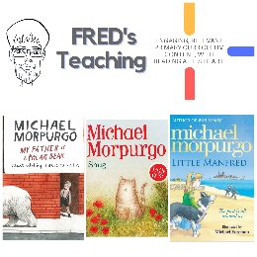 | 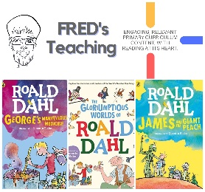 | 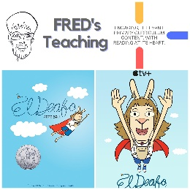 | 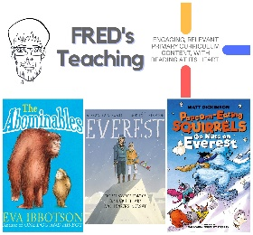 | 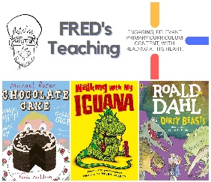 | 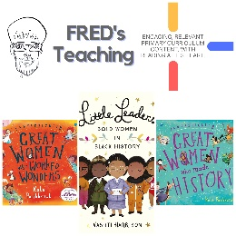 | 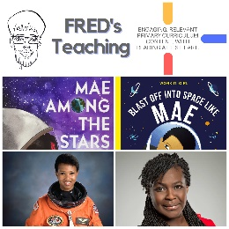 | 

