
  St John the Baptist
  Reading
  Progression Document
 |  |  | Word reading
EYFS | Year 1 |  | Year 2 | Year 3 | Year 4 | Year 5 |  | Year 6
ELG  Say a sound for each letter in the alphabet and know at least 10 digraphs.  Read words consistent with their phonic knowledge by sound blending.  Read aloud simple sentences and books that are consistent with their phonic knowledge, including some common exception words.  KS1 readiness objectives  Developing phonemic knowledge through SoundsWrite. | Apply your phonic knowledge and skills as the route to decode words.  Respond speedily with the correct sound to graphemes for all 40+ phonemes, including, where applicable, alternative sounds for graphemes.  Read accurately by blending sounds in unfamiliar words containing GPCs that have been taught.  Read common exception words, noting unusual correspondences between spelling and sound and where these occur in the word. |  | Continue to apply your phonic knowledge and skills to decode words until automatic decoding has become embedded and reading is fluent.  Read accurately by blending the sounds in words that contain the  graphemes taught so far, especially recognising alternative sounds for graphemes.  Read accurately words of two or more syllables that contain the same graphemes as above.  Read words containing common suffixes. | Apply your growing knowledge of root words, prefixes and suffixes (etymology and morphology) both to read aloud and to understand the meaning of new words meet.  Read further exception words, noting the unusual correspondences between spelling and sound, and where these occur in the word. | Apply your growing knowledge of root words, prefixes and suffixes (etymology and morphology) both to read aloud and to understand the meaning of new words you meet.  Read further exception words, noting the unusual correspondences between spelling and sound, and where these occur in the word. | Apply your growing knowledge of root words, prefixes and suffixes (morphology and etymology) both to read aloud and to understand the meaning of new words that they meet. |  | Apply your knowledge of root words, prefixes and suffixes (morphology and etymology) both to read aloud and to understand the meaning of new words that you meet.

 | Read words containing taught GPCs and –s, -es, -ing, -ed, -er and -est endings.  Read other words of more than one syllable that contain taught GPCs.  Read words with contractions (e.g., I’m, I’ll, we’ll) and  understand that the apostrophe represents the omitted letter(s).  Read aloud accurately books that are consistent with your phonic knowledge and that do not require you to use other strategies to work out words.  Re-read these books to build up your fluency and confidence in word reading. | Read further common exception words, noting unusual correspondences between spelling and sound where these occur in the word.  Read most words quickly and accurately, without overt sounding and blending, when they have been frequently encountered.  Read aloud books closely matched to your improving phonic knowledge, sounding out unfamiliar words accurately, automatically and without undue hesitation.  Re-read these books to build up their fluency and confidence in word reading.

Comprehension 1
EYFS and KS1: Develop pleasure in reading, motivation to read, vocabulary and understanding by…
KS2:Maintain positive attitudes to reading and understanding of what you read and…
EYFS | Year 1 | Year 2 | Year 3 | Year 4 | Year 5 | Year 6
ELG  Listen attentively and respond to what they hear with relevant questions, comments and actions when being read to and during whole class discussions.  Use and understand recently introduced vocabulary during discussions about stories, non-fiction, rhymes and poems during role-play.  KS1 readiness objectives  Developing their skills and abilities in retelling familiar stories.  Recognising that books have information that helps them to learn. | Listen to and discuss a wide range of poems, stories and non-fiction at a level beyond that at which you can read independently.  Be encouraged to link what you read or hear read to your own personal experiences.  Become very familiar with key stories, fairy stories and traditional tales, retelling them and considering their  particular characteristics.  Recognise and join in with predictable phrases.  Learn to appreciate rhymes and poems, and able to recite some by heart. | Listen to, discuss and express your views about a wide range of contemporary and  classic poetry, stories and non-fiction at a level beyond that at which you can read independently.  Discussing the sequence of events in books and how items of information are related.  -Become increasingly familiar with and retelling a wider range of stories, fairy stories and traditional tales.  Be introduced to nonfiction books that are structured in different ways. | Listen to and discuss a wide range of fiction, poetry, plays, non-fiction and reference or text books.  Read books that are structured in different ways and reading for a range of purposes.  Use a dictionary to check the meaning of words that you have read.  Increase your familiarity with a wide range of books, including fairy stories, myths and legends, and retell some of these orally. | Listen to and discuss a wide range of fiction, poetry, plays, nonfiction and reference or text books.  Read books that are structured in different ways and reading for a range of purposes.  Use a dictionary to check the meaning of words that you have read.  Increase your familiarity with a wide range of books, including fairy stories, myths and legends, and retelling some of these orally. | Continue to read and discuss an increasingly wide range of fiction, poetry, plays, nonfiction and reference books or textbooks.  Read books that are structured in different ways and reading for a range of purposes.  Increase familiarity with a wide range of books, inc myths, legends & traditional stories, modern fiction, fiction from our literary heritage & books from other cultures & traditions.  Recommend books that you have read to your peers, giving reasons for your choices. | Continue to read and discuss an increasingly wide range of fiction, poetry, plays, nonfiction and reference books or textbooks.  Read books that are structured in different ways and reading for a range of purposes.  Increase familiarity with a wide range of books, inc myths, legends & traditional stories, modern fiction, fiction from our literary heritage & books from other cultures & traditions.  Recommend books that you have read to your peers, giving reasons for your choices.
 | Discuss word meanings, linking new meanings to those already known. | Recognise simple recurring literary language in stories and poetry.  Discuss and clarify the meanings of words, linking new meanings to known vocabulary; discuss your favourite words and phrases.  Continue to build up a repertoire of poems learnt by heart, appreciating these and reciting some, with appropriate intonation to make the meaning clear. | Identify themes and conventions in a wide range of books.  Prepare simple poems and play scripts to read aloud and to perform, show understanding through intonation, tone, volume and action.  Discuss words and phrases that capture the reader’s interest and imagination.  Recognise some different forms of poetry (e.g. free verse, narrative poetry). | Identify themes and conventions in a wide range of books.  Prepare simple poems and play scripts to read aloud and to perform, showing understanding through intonation, tone, volume and action.  Discuss words and phrases that capture the reader’s interest and imagination.  Recognise some different forms of poetry (e.g. free verse, narrative poetry). | Identify and discuss themes and conventions in and across a wide range of writing.  Make comparisons within and across books.  Learn a wider range of poetry by heart.  Prepare poems and plays to read aloud and to perform, showing understanding through intonation, tone and volume so that the meaning is clear to an audience. | Identify and discuss themes and conventions in and across a wide range of writing.  Make comparisons within and across books.  Learn a wider range of poetry by heart.  Prepare poems and plays to read aloud and to perform, showing understanding through intonation, tone and volume so that the meaning is clear to an audience.

Comprehension 2
EYFS and KS1: Understand both the books you can already read accurately and fluently and those you listen to and…
KS2: Understand what you have read, in books you can read independently and…
EYFS | Year 1 | Year 2 | Year 3 | Year 4 | Year 5 | Year 6
ELG  Demonstrate an understanding of what has been read to them by retelling stories and narratives using their own words and recently introduced vocabulary.  Understand the past through settings, characters and events encountered in books read in class and storytelling.  Invent, adapt and recount narratives with peers and their teachers  KS1 readiness objectives  Routinely accessing picture books and stories.  Listening to others expressively tell stories.  Learning that stories and books can put them in imaginary worlds full of adventure and excitement | Draw on what you already know or on background information and vocabulary provided by the teacher.  Check that the text makes sense to you as you read and correcting inaccurate reading.  Discuss the significance of the title and events.  -Make inferences on the basis of what is being said and done.  Predict what might happen on the basis of | Draw on what you already know or on background information and vocabulary provided by the teacher.  Check that the text makes sense to you as they read and correcting inaccurate reading.  Make inferences on the basis of what is being said and done .  Answer and ask questions.  Predict what might happen on the basis of what has been read so far. | Check that the text makes sense to you, discuss your understanding and explaining the meaning of words in context.  Ask questions to improve your understanding of a text.  Draw inferences such as inferring characters’ feelings, thoughts and motives from your actions, and justifying inferences with evidence. | Check that the text makes sense to you, discuss your understanding and explaining the meaning of words in context.  Ask questions to improve your understanding of a text.  Draw inferences such as inferring characters’ feelings, thoughts and motives from your actions, and justifying inferences with evidence. | Check that the book makes sense to you, discussing your understanding and exploring the meaning of words in context.  Ask questions to improve your understanding.  Draw inferences such as inferring characters’ feelings, thoughts and motives from their actions, and justifying inferences with evidence.  Predict what might happen from details stated and implied. | Check that the book makes sense to you, discussing your understanding and exploring the meaning of words in context.  Ask questions to improve your understanding.  Draw inferences such as inferring characters’ feelings, thoughts and motives from their actions, and justifying inferences with evidence.  Predict what might happen from details stated and implied.

. | what has been said so far.  Participate in discussion about what is read to you, taking turns and listening to what others say.  Explain clearly your understanding of what is read to you. | Participate in discussion about books, poems and other works that are read to you and those that you can read for yourself, taking turns and listening to what others say.  Explain and discuss your understanding of books, poems and other material, both those that you listen to and those that you read for yourselves. | Predict what might happen from details stated and implied.  Identify main ideas drawn from more than one paragraph and summarise these.  Identify how language, structure and presentation contribute to meaning.  Retrieve and record information from non-fiction.  Participate in discussion about both books that are read to you and those you can read for yourself, taking turns and listening to what others say. | Predict what might happen from details stated and implied.  Identify main ideas drawn from more than one paragraph and summarise these.  Identify how language, structure and presentation contribute to meaning.  Retrieve and record information from non-fiction.  Participate in discussion about both books that are read to you and those you can read for yourself, taking turns and listening to what others say. | Summarise the main ideas drawn from more than one paragraph, identifying key details that support the main ideas.  Identify how language, structure and presentation contribute to meaning.  Discuss and evaluate how authors use language, including figurative language, considering the impact on the reader.  Distinguish between statements of fact and opinion.  Retrieve, record and present information from non-fiction. | Summarise the main ideas drawn from more than one paragraph, identifying key details that support the main ideas.  Identify how language, structure and presentation contribute to meaning.  Discuss and evaluate how authors use language, including figurative language, considering the impact on the reader.  Distinguish between statements of fact and opinion.  Retrieve, record and present information from non-fiction.
 |  |  |  |  | Participate in discussions about books that are read to you and those you can read for yourself, building on your own and others’ ideas and challenging views courteously.  Explain and discuss your understanding of what you have read, including through formal presentations and debates, maintaining a focus on the topic and using notes where necessary.  Provide reasoned justifications for your views. | Participate in discussions about books that are read to you and those you can read for yourself, building on your own and others’ ideas and challenging views courteously.  Explain and discuss your understanding of what you have read, including through formal presentations and debates, maintaining a focus on the topic and using notes where necessary.  Provide reasoned justifications for your views.

Year 6 – SPRING 1
Week 1: 02/01/23 | Week 2: 09/01/23 | Week 3: 16/01/23 | Week 4: 23/01/23 | Week 5: 30/01/23 | Week 6: 06/02/23
Theme: Birds. | Theme: Destination – Malawi. | Theme: Best Books of 2021 v2. | Theme: Chinese New Year v2. | Theme: Awesome Series – The Inheritance Cycle. | Theme: Modern vs Classic Adventure Story 2.
Extracts:  - Birds (non-fiction).  - Magnificent Birds (non-fiction).  - Extraordinary Birds (non-fiction). | Extracts:  - The Boy Who Harnessed the Wind.  - The Boy Who Harnessed the Wind (Netflix movie trailer).  - BBC Malawi Country Profile (non-fiction). | Extracts:  - The Chime Seekers.  - Freeze.  - Shadowghast. | Extracts:  - All About China (non-fiction).  - The Kite Runner.  - Chinese New Year: Lets Celebrate (YouTube video). | Extracts:  - Eragon.  - Eldest.  - Brisingr. | Extracts:  - The Hobbit.  - Silverfin (Graphic novel).  - When We Got Lost in Dreamland.
23 pieces of Tier 2 and Tier 3 vocabulary.  21 retrieval questions.  3 writing challenges. | 21 pieces of Tier 2 and Tier 3 vocabulary.  21 retrieval questions.  3 writing challenges. | 21 pieces of Tier 2 and Tier 3 vocabulary.  21 retrieval questions.  3 writing challenges. | 26 pieces of Tier 2 and Tier 3 vocabulary.  21 retrieval questions.  3 writing challenges. | 24 pieces of Tier 2 and Tier 3 vocabulary.  21 retrieval questions.  3 writing challenges. | 19 pieces of Tier 2 and Tier 3 vocabulary.  21 retrieval questions.  3 writing challenges.
16 EXTENSION questions to stretch learners. | 18 EXTENSION questions to stretch learners. | 12 EXTENSION questions to stretch learners. | 15 EXTENSION questions to stretch learners. | 18 EXTENSION questions to stretch learners. | 11 EXTENSION questions to stretch learners.
Content Domains covered: 2a, 2b, 2c, 2d, 2e, 2f, 2g, 2h | Content Domains covered: 2a, 2b, 2c, 2d, 2e, 2f, 2g, 2h | Content Domains covered: 2a, 2b, 2c, 2d, 2e, 2f, 2g, 2h | Content Domains covered: 2a, 2b, 2c, 2d, 2e, 2f, 2g, 2h | Content Domains covered: 2a, 2b, 2c, 2d, 2e, 2f, 2g, 2h | Content Domains covered: 2a, 2b, 2c, 2d, 2e, 2f, 2g, 2h
Website Link | Website Link | Website Link | Website Link | Website Link | Website Link
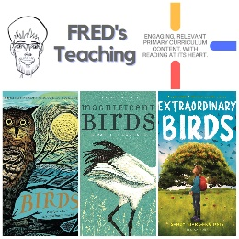 | 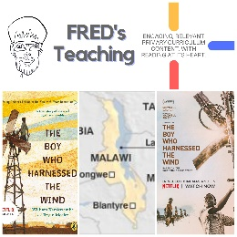 | 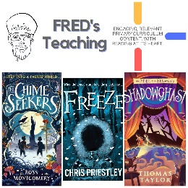 | 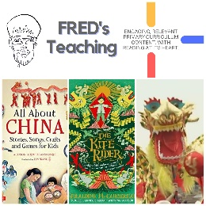 | 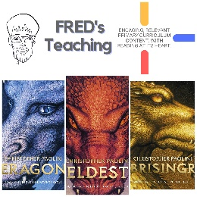 | 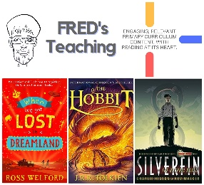

Year 6 - SPRING
Week 1: 20/02/23 | Week 2: 27/02/23 | Week 3: 06/03/23 | Week 4: 13/03/23 | Week 5: 20/03/23 | Week 6: 27/03/23
Theme: Book Series Beginnings | Theme: Best Books of 2022 (2nd March is World Book Day) | Theme: Awesome Women: Malala (8th March is International Women’s Day) | Theme: British Science Week | Theme: Disability Positivity (21st March is World Down Syndrome Day) | Theme: The Human Body
Extracts:  - Artemis Fowl.  - Saffy’s Angel.  - Wildwood | Extracts:  - Season of Secrets.  - The Silver Arrow.  - When the War Came Home. | Extracts:  - First Names: Malala Yousafzai (non-fiction)  - Malala: The Girl who Stood Up for Education and Changed the World  - Malala Yousafzai Nobel Prize Acceptance Speech | Extracts:  - The Story of Planet Earth (non-fiction).  - This Book is Full of Brains (non-fiction).  - Extinct: Lisowicia (non-fiction). | Extracts:  - I Am Not A Label (non-fiction).  - Turtle Boy.  - The Secret of Haven Point (On Language – A Note From The Author extract). | Extracts:  - The Virus (non-fiction).  - The Third Chimpanzee (non-fiction).  - Humanatomy (non-fiction).
22 pieces of Tier 2 and Tier 3 vocabulary.  21 retrieval questions.  3 writing challenges. | 21 pieces of Tier 2 and Tier 3 vocabulary.  21 retrieval questions.  3 writing challenges. | 24 pieces of Tier 2 and Tier 3 vocabulary.  21 retrieval questions.  3 writing challenges. | 21 pieces of Tier 2 and Tier 3 vocabulary.  21 retrieval questions.  3 writing challenges. | 21 pieces of Tier 2 and Tier 3 vocabulary.  21 retrieval questions.  3 writing challenges. | 23 pieces of Tier 2 and Tier 3 vocabulary.  21 retrieval questions.  3 writing challenges.
18 EXTENSION questions to stretch learners. | 18 EXTENSION questions to stretch learners. | 10 EXTENSION questions to stretch learners. | 18 EXTENSION questions to stretch learners. | 18 EXTENSION questions to stretch learners. | 18 EXTENSION questions to stretch learners.
Content Domains covered: 2a, 2b, 2c, 2d, 2e, 2f, 2g, 2h | Content Domains covered: 2a, 2b, 2c, 2d, 2e, 2f, 2g, 2h | Content Domains covered: 2a, 2b, 2c, 2d, 2e, 2f, 2g, 2h | Content Domains covered: 2a, 2b, 2c, 2d, 2e, 2f, 2g, 2h | Content Domains covered: 2a, 2b, 2c, 2d, 2e, 2f, 2g, 2h | Content Domains covered: 2a, 2b, 2c, 2d, 2e, 2f, 2g, 2h
Website Link | Website Link | Website Link | Website Link | Website Link | Website Link
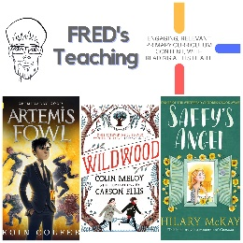 | 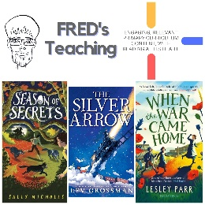 | 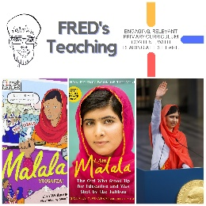 | 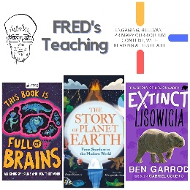 | 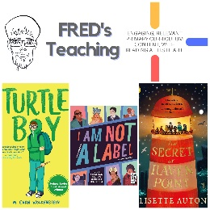 | 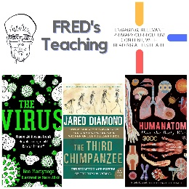
sweltering  testy  unconvinced  pathetic  tinge  trembling  ambush  hunted  protested  eluded  absorbed  enveloping  unpicking  wailed  spellbound  talons  responsibility  abducted  drifting  determination  brandished  awkwardly | arguments  rustle  smattering  pky  ordnance  exotic  faded  portion  plonk  Fourpence  tradition  arithmetic  margarine  quota | examined  thoroughly  impeccably  breathlessly  smooch  promptly  presence  destined  aspirations  paediatrician  finite  humbled  inauguration  hypocritical  detractors | generations  gravity  catastrophic  Supernovas  clustered  substances  particles  quintillion  powerful  connect  discovered  parietal  lobe  ridges  revision  succeeding  resistance  physical  limitless  biological  harmless | humble  vibrant  exquisite  profoundly  melancholy  innovative  destined  guffawed  taunt  looming  startled  reluctantly  jitter  traumatic  fortune  conscious  impairments  empowering  respect  pressure  feature | terrifting  overhwlemed  chemicals  immune  fragile  humble  parched  geyers  mammal  perserved  visible  species  genetic  gene  compared  fossil  operates  various  deliverately  autcomatically  contracting  prime  versatile  elastic

