Ball Striking/Fielding
UKS2
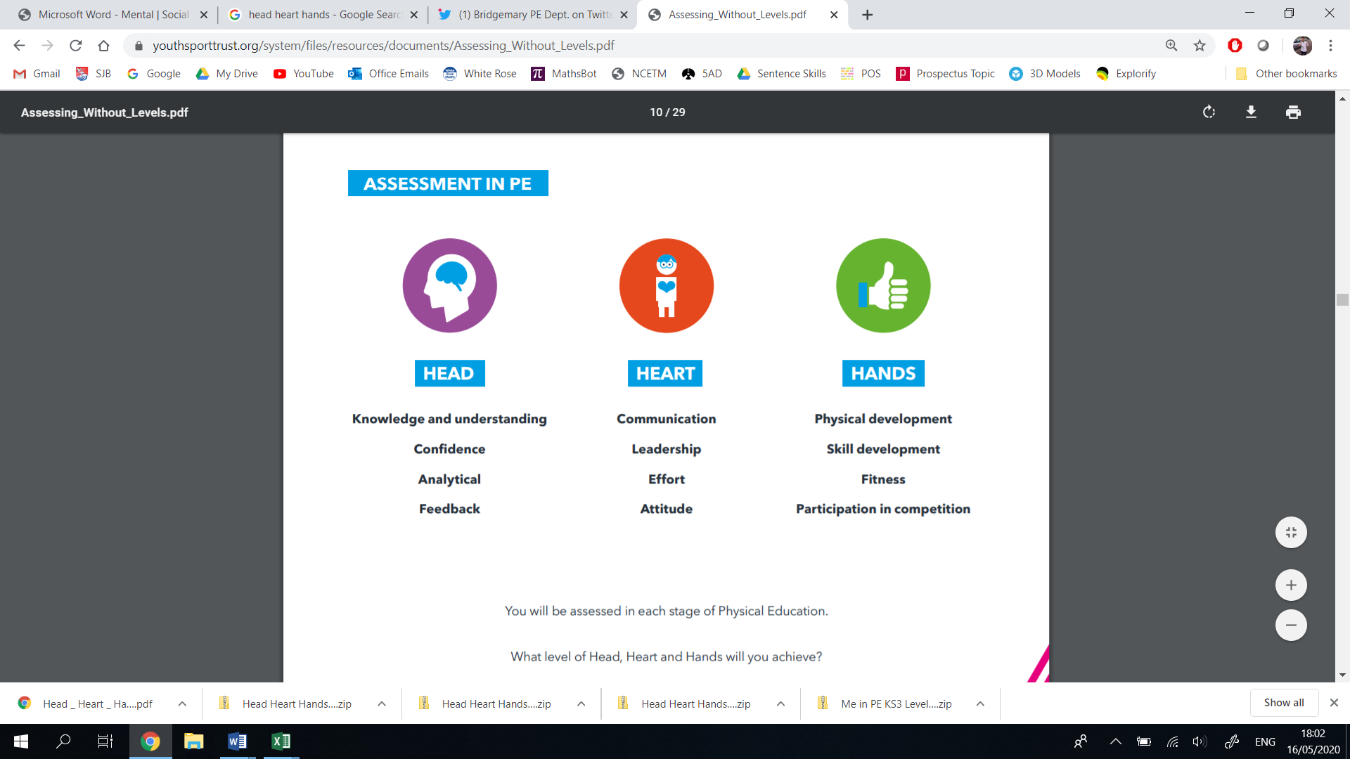
Thinking | Behaviour | Physical | Thinking | Behaviour | Physical
- Decision Making  - Confidence  - Creativity  - Analyticity | - Effort  - Communication  - Values  - Healthy Lifestyle | - Physical Development  - Skill Development  - Competitive Development  - Active Lifestyle | - Decision Making  - Confidence  - Creativity  - Analyticity | - Effort  - Communication  - Values  - Healthy Lifestyle | - Physical Development  - Skill Development  - Competitive Development  - Active Lifestyle
Year 6 |  |  | Year 5
Vocabulary: block, front foot, back foot, sweep, glance, leave. pace, line, spin, trajectory, target, long-barrier |  |  | Vocabulary: block, front foot, back foot, sweep, glance, leave. pace, line, spin, trajectory, target, long-barrier
I can decide which bowling technique is appropriate for which sport/situation.  I can confidently position myself around the field, ensuring I am integral to my teams’ success.  I can creatively outwit my opponent through using a variety of bowling methods (pace, line, spin, trajectory, target)  I can creatively outwit my opponent through using a variety of batting methods (block, front foot, back foot, sweep, glance, leave)  I can consistently analyse my choices, adjusting them accordingly. | I can compare my efforts to previous ones, demonstrating an improvement.  I can discuss/share my improvements with a partner.  I can show true sportsmanship through honesty during competitive situations.  I can show an endeavour to take risks and attempt new striking/bowling/fielding techniques.  I can acknowledge how repetitive strain injury can occur. | I can perform an over arm bowl with speed and accuracy.  I can perform an underarm throw with speed and accuracy.  I can perform reliable fielding techniques (long barrier, scoop and throw) to be efficient.  I can perform running, collecting and catching fluently, in combination.  I can strike a ball in various directions, using a variety of techniques: block, front foot, back foot, sweep, glance, leave.  I can perform competitively against my peers. | I can decide which bowling technique is appropriate for which sport/situation.  I can position myself around the field, ensuring I am contributing to the game.  I can creatively outwit my opponent through using a variety of bowling methods (pace, line, spin, trajectory, target)  I can creatively outwit my opponent through using a variety of batting methods (block, front foot, back foot, sweep, glance, leave)  I can analyse my choices, adjusting them accordingly. | I can compare my efforts to previous ones, demonstrating an improvement.  I can discuss/share my improvements with a partner.  I can show true sportsmanship through honesty during competitive situations.  I can show an endeavour to take risks and attempt new striking/bowling/fielding techniques. | I can perform an over arm bowl with accuracy, in combination with a run up.  I can perform an underarm throw with speed and accuracy.  I can perform reliable fielding techniques (long barrier, scoop and throw), attempting to match them to the specific situation.  I can perform running, collecting and catching fluently with my dominant hand, sometimes in combination.  I can strike a ball in various directions, using a variety of techniques: block, front foot, back foot, leave.
LKS2
Thinking | Behaviour | Physical | Thinking | Behaviour | Physical
- Decision Making  - Confidence  - Creativity  - Analyticity | - Effort  - Communication  - Values  - Healthy Lifestyle | - Physical Development  - Skill Development  - Competitive Development  - Active Lifestyle | - Decision Making  - Confidence  - Creativity  - Analyticity | - Effort  - Communication  - Values  - Healthy Lifestyle | - Physical Development  - Skill Development  - Competitive Development  - Active Lifestyle
Year 4 |  |  | Year 3
Vocabulary: striking, fielding, position, keeping, bowling, trajectory, line, pace, off-side, legside, stumps, anticipation, front foot, back foot. |  |  | Vocabulary: striking, fielding, position, keeping, bowling, trajectory, line, pace, off-side, legside, stumps, anticipation, front foot, back foot.
I can experiment with different bowling techniques, analysing their strengths and weaknesses, linking them to specific in-game situations.  I can show an understanding of important roles/positions in the field, placing myself accordingly.  I can begin to outwit my opponent by selecting different bowling tactics to suit the situation (underarm, overarm, leg side, off-side, target)  I can begin to outwit my opponent by selecting different batting tactics to suit the situation (power strike, placement strike, leave) | I can show a valiant effort to improve my technique.  I can perform my learning with vigour and desire.  I can show true sportsmanship through honesty during competitive situations.  I can show an endeavour to take risks and attempt new striking/bowling/fielding techniques.  I can understand how recovery is important in striking/fielding sports. | I can perform an over arm bowl with accuracy.  I can perform an underarm throw with speed and accuracy.  I can perform reliable fielding techniques (long barrier, scoop and throw), attempting to match them to the specific situation.  I can perform running, collecting and catching fluently with my dominant hand, sometimes in combination.  I can hold and control a variety of striking instruments with the correct technique (e.g. tennis – V grip, cricket – downward V grip)  I can strike a ball in various directions, using a variety of techniques: block, front foot, back foot, leave. | I can experiment with different bowling techniques, explaining their strengths and weaknesses.  I can show some understanding of using space as a striker/hitter.  I can show some understanding of using space as a fielder/defender.  I can use the underarm throw creatively, changing its speed, direction, target and trajectory.  I can show confidence in my hand-eye coordination when using a striking instrument, showing control of direction (forehand, backhand, overhead) | I can show a valiant effort to improve my technique.  I can perform my learning with vigour and desire.  I can show an endeavour to take risks and attempt new striking/bowling/fielding techniques.  I can show a valiant effort to improve my technique.. | I can begin to bowl a ball over arm, showing some control with its speed and direction.  I can perform an underarm throw in combination with moving/jumping.  I can perform running, collecting and catching with my dominant hand, sometimes in combination.  I can hold and control a variety of striking instruments with the correct technique (e.g. tennis – V grip, cricket – downward V grip)  I can strike a ball with a striking instrument, sometimes showing control of direction (forehand, backhand, overhead)
KS1
Thinking | Behaviour | Physical | Thinking | Behaviour | Physical
- Decision Making  - Confidence  - Creativity  - Analyticity | - Effort  - Communication  - Values  - Healthy Lifestyle | - Physical Development  - Skill Development  - Competitive Development  - Active Lifestyle | - Decision Making  - Confidence  - Creativity  - Analyticity | - Effort  - Communication  - Values  - Healthy Lifestyle | - Physical Development  - Skill Development  - Competitive Development  - Active Lifestyle
Year 2 |  |  | Year 1
Vocabulary: striking, fielding, collecting, catching, shot, stroke, impact, rounders, cricket, tennis, racquet, bat, ball, target, stationary |  |  | Vocabulary: striking, fielding, collecting, catching, shot, stroke, impact, rounders, cricket, tennis, racquet, bat, ball, target, stationary
I can select which throw is appropriate for which situation (underarm or overarm)  I can show confidence in my dominant hand.  I can strike stationary objects in creative ways (upwards, downwards, sidewards, forwards, backwards), sometimes hitting them toward a target  I can analyse my underarm throw, adjusting various parts of it to ensure I am consistently accurate.  I can show some confidence in my hand-eye coordination when using a striking instrument, by hitting a ball efficiently. | I can show resilience when learning new skills.  I can perform my learning with vigour and desire.  I can speak about why we use different throwing techniques.  I can evaluate my performance against a score.  I can understand how diet is important to a striking/fielding athlete. | I can throw a ball overarm for distance.  I can perform an underarm throw for accuracy at varying distances., with consistent results.  I can perform running, collecting and catching with my dominant hand.  I can hold and control a variety of striking instruments safely.  I can strike a stationary ball toward a target. | I can make decisions based around which striking instrument to use.  I can select which throw is appropriate for which situation (underarm or overarm)  I can show confidence in my dominant hand.  I can strike stationary objects in creative ways (upwards, downwards, sidewards, forwards, backwards)  I can analyse my underarm throw, expressing whether it was successful or not.  I can show some confidence in my hand-eye coordination when using a striking instrument, by hitting a ball across the floor. | I can show resilience when learning new skills.  I can perform my learning with vigour and desire.  I can speak about why we use different throwing techniques.  I can speak about why we need to strike a ball.  I can speak about why we need to collect a ball.  I can understand how safety is extremely important in striking/fielding sports. | I can begin to throw a ball overarm for distance.  I can perform an underarm throw for accuracy at varying distances.  I can perform running, collecting and catching in isolation.  I can hold and control a variety of striking instruments safely.  I can strike a stationary ball, sometimes toward a target.

EYFS
Thinking |  | Behaviour | Physical |  | Thinking | Behaviour |  | Physical
- Decision Making  - Confidence  - Creativity  - Analyticity |  | - Effort  - Communication  - Values  - Healthy Lifestyle | - Physical Development  - Skill Development  - Competitive Development  - Active Lifestyle |  | - Decision Making  - Confidence  - Creativity  - Analyticity | - Effort  - Communication  - Values  - Healthy Lifestyle |  | - Physical Development  - Skill Development  - Competitive Development  - Active Lifestyle
Reception |  |  |  |  | Nursery
Vocabulary: strong, firm, gentle, heavy, reach, tense, floppy, travel, follow, lead, copy, slither, gallop, walk, climb, crawl, slide, speed, direction, obstacles |  |  |  |  | Vocabulary: strong, firm, gentle, heavy, reach, tense, floppy, travel, follow, lead, copy, slither, gallop, walk, climb, crawl, slide, speed, direction, obstacles
 |  |  |  |  | Early Learning Goal: Children know the importance for good health of physical exercise, and a healthy diet, and talk about ways to keep healthy and safe. They manage their own basic hygiene and personal needs successfully, including dressing and going to the toilet independently
 |  |  |  |  | Early Learning Goal Children express themselves effectively, showing awareness of listeners’ needs. They use past, present and future forms accurately when talking about events that have happened or are to happen in the future. They develop their own narratives and explanations by connecting ideas or events.
I can show an understanding of how to transport and store equipment safely.  I can understand the use of objects (e.g. “What do we use to strike this ball?’)  I can show an understanding of prepositions such as ‘under’, ‘on top’, ‘behind’ by carrying out an action.  I can respond to simple instructions, e.g. pass the ball to your partner.  I can respond to instructions involving a two-part sequence. | I can show an awareness about exercise, its effect on my body and the positive contribution it can make to my health.  I can notice the changes in my body after exercise, such as my heart beating faster.  I can understand we need to rest after exercise because our body is tired.  I can build up vocabulary that reflects the breadth of my experiences.  I can understand how fruit and vegetables are in important part of an athlete’s diet. |  |  | I can manipulate different sized objects (balls, quoits, bean bags) around my body, showing control.  I can run skilfully and negotiate space successfully, adjusting speed or direction to avoid obstacles.  I can catch a large ball.  I can stop a ball from moving by trapping it with my hands.  I can begin to catch a small ball from a short distance.  I can show an increasing control over an object in pushing, patting, throwing or kicking.  I can show a preference for a dominant hand by holding and using various striking instruments. | I can show some understanding of good practices with regard to exercise, eating, sleeping and hygiene and how it can contribute to good health.  I can show an understanding of how to transport and store equipment safely.  I can understand the use of objects (e.g. “What do we use to strike this ball?’)  I can show an understanding of prepositions such as ‘under’, ‘on top’, ‘behind’ by carrying out an action.  I can respond to simple instructions, e.g. pass the ball to your partner.  I can respond to instructions involving a two-part sequence. |  | I can show an awareness about exercise, its effect on my body and the positive contribution it can make to my health.  I can notice the changes in my body after exercise, such as my heart beating faster.  I can understand we need to rest after exercise because our body is tired.  I am growing more independent, trying things for myself in controlled environments (without adult guidance).  I can build up vocabulary that reflects the breadth of my experiences.  I can show an interest in turn-taking, waiting until someone else has finished, listening to others and using expressions such as “please”, “thank you” and “can I…? |  | I can move freely and with pleasure and confidence in a range of ways, such as slithering, shuffling, rolling, crawling, walking, running, jumping, skipping, sliding and hopping.  I can run skilfully and negotiate space successfully, adjusting speed or direction to avoid obstacles.  I can catch a large ball.  I can experiment with different ways of moving.  I can show an increasing control over an object in pushing, patting, throwing or kicking.  I can show a preference for a dominant hand.

