Outdoor and Adventurous Activities
UKS2
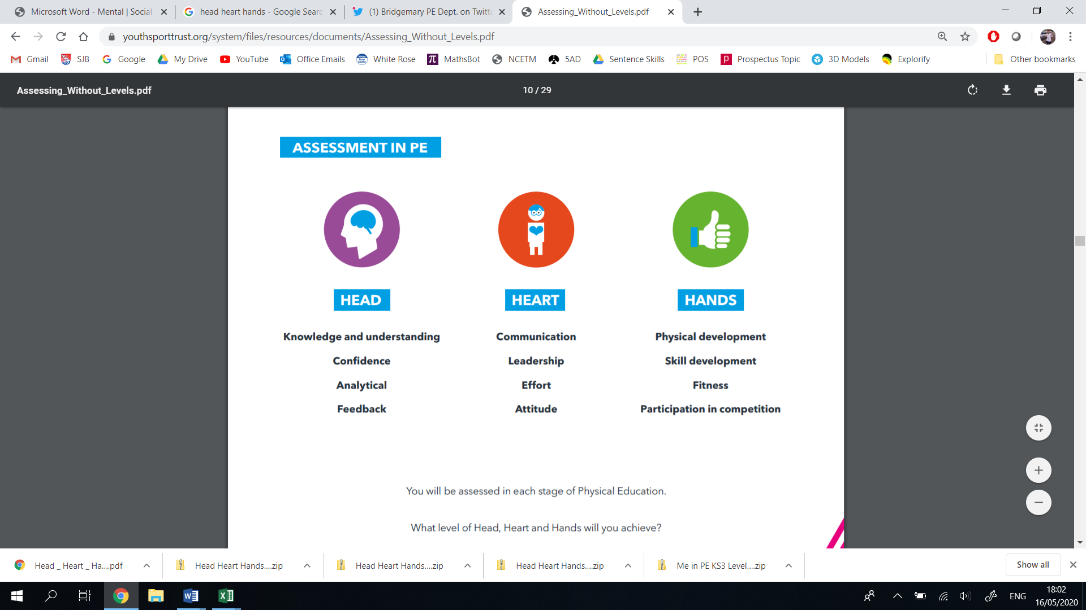
Thinking | Behaviour | Physical | Thinking | Behaviour | Physical
- Decision Making  - Confidence  - Creativity  - Analyticity | - Effort  - Communication  - Values  - Healthy Lifestyle | - Physical Development  - Skill Development  - Competitive Development  - Active Lifestyle | - Decision Making  - Confidence  - Creativity  - Analyticity | - Effort  - Communication  - Values  - Healthy Lifestyle | - Physical Development  - Skill Development  - Competitive Development  - Active Lifestyle
Year 6 |  |  | Year 5
Vocabulary: navigation, orientation, compass, bearing, contours, course, checkpoint, obstacle, communication, resilience, fieldwork, geographical, endurance, route, strategy |  |  | Vocabulary: navigation, orientation, compass, bearing, contours, course, checkpoint, obstacle, communication, resilience, fieldwork, geographical, endurance, route, strategy
I can demonstrate effective decision making to reach a goal.  I can use map skills confidently to orientate when participating in OAA activities.  I can create imaginative games using equipment provided.  I can reflect on when and how I was successful, and alter my methods to improve my performance.  I can demonstrate problem solving skills using previous experience to work through a challenge.  I can show resilience and resolve when situations become challenging. | I can collaborate effectively with a group, sharing and listening to responses respectfully.  I can pool ideas, selecting and applying the most effective methods.  I can solve problems with a group, maintaining a positive working environment throughout.  I can show leadership by guiding other children through various parts of the challenge.  I can show Catholic and British Values throughout the challenges.  I can show an interest in competing in the OAA activities provided by the wider community. | I can use the 8 points of a compass, 4 and 6-figure grid references, symbols and key  (KS2– Geography)  I can use fieldwork skills to observe, measure, record and present the human and physical features in the local area using a range of methods, including sketch maps, plans and graphs, and digital technologies.  (KS2– Geography)  I can navigate my way through orienteering style activities.  I can demonstrate my skills by tracking and following a course.  I can draw on my previous map skills, making trails and journeys for other children to follow.  I can demonstrate control and endurance through orienteering style activities. | I can demonstrate effective decision making to reach a goal.  I can use map skills confidently to orientate when participating in OAA activities.  I can create imaginative games using equipment provided.  I can reflect on when and how I was successful, and alter my methods to improve my performance.  I can demonstrate critical thinking to solve a task.  I can show resilience and resolve when situations become challenging. | I can collaborate effectively with a group, sharing and listening to responses respectfully.  I can pool ideas, selecting and applying the most effective methods.  I can solve problems with a group, maintaining a positive working environment throughout.  I can show leadership by guiding other children through various parts of the challenge.  I can show Catholic and British Values throughout the challenges.  I can show an interest in competing in the OAA activities provided by the wider community. | I can use the 8 points of a compass, 4 and 6-figure grid references, symbols and key  (KS2– Geography)  I can use fieldwork skills to observe, measure, record and present the human and physical features in the local area using a range of methods, including sketch maps, plans and graphs, and digital technologies.  (KS2– Geography)  I can navigate my way through orienteering style activities.  I can demonstrate my skills by tracking and following a course.  I can demonstrate control and endurance through orienteering style activities.
LKS2
Thinking | Behaviour | Physical | Thinking | Behaviour | Physical
- Decision Making  - Confidence  - Creativity  - Analyticity | - Effort  - Communication  - Values  - Healthy Lifestyle | - Physical Development  - Skill Development  - Competitive Development  - Active Lifestyle | - Decision Making  - Confidence  - Creativity  - Analyticity | - Effort  - Communication  - Values  - Healthy Lifestyle | - Physical Development  - Skill Development  - Competitive Development  - Active Lifestyle
Year 4 |  |  | Year 3
Vocabulary: navigation, orientation, compass, bearing, contours, course, checkpoint, obstacle, communication, resilience, fieldwork, geographical, endurance, route, strategy |  |  | Vocabulary: navigation, orientation, compass, bearing, contours, course, checkpoint, obstacle, communication, resilience, fieldwork, geographical, endurance, route, strategy
I can demonstrate decision making to reach a goal.  I can identify key features of a map, including symbols, to help navigate around a course.  I can create imaginative games using equipment provided.  I can plan and apply strategies to solve a challenge.  I can reflect on when and why I was successful, offering suggestions for improvement to my or other children’s groups. | I can work effectively with a small group, sharing and listening to responses respectfully.  I can accurately give instructions, using clear and concise language.  I can show patience and tolerance when working in a group.  I can show leadership by helping other children through various parts of the challenge.  I can show Catholic and British Values throughout the challenges. | I can use the 4 main points of a compass, 4 figure grid references, symbols and key  (KS2– Geography)  I can use fieldwork skills to observe and record human and physical features in the local area using a range of methods, including sketch maps, plans and graphs, and digital technologies.  (KS2– Geography)  I can navigate my way through orienteering style activities.  I can demonstrate my skills by following a course.  I can demonstrate control and endurance through orienteering style activities. | I can demonstrate decision making to reach a goal.  I can identify key features of a map, including symbols.  I can create imaginative games using equipment provided.  I can plan and attempt to apply strategies to solve a challenge.  I can reflect on when and why I was successful.  I can member and follow instructions given, carrying them out in order. | I can work effectively with a small group, sharing and listening to suggestions.  I can show a determination to complete the challenge.  I can show cooperation by adapting my game or work for my partner’s ability.  I can show patience and tolerance when working in a group.  I can show Catholic and British Values throughout the challenges. | I can use a compass to orientate myself  (KS2– Geography)  I can use fieldwork skills to observe physical features in the local area using a range of methods, including sketch maps  (KS2– Geography)  I can navigate my way through orienteering style activities.  I can demonstrate my skills by following a course.  I can demonstrate a variety of fundamental movement skills when completing a challenge.

