Invasion Games
UKS2
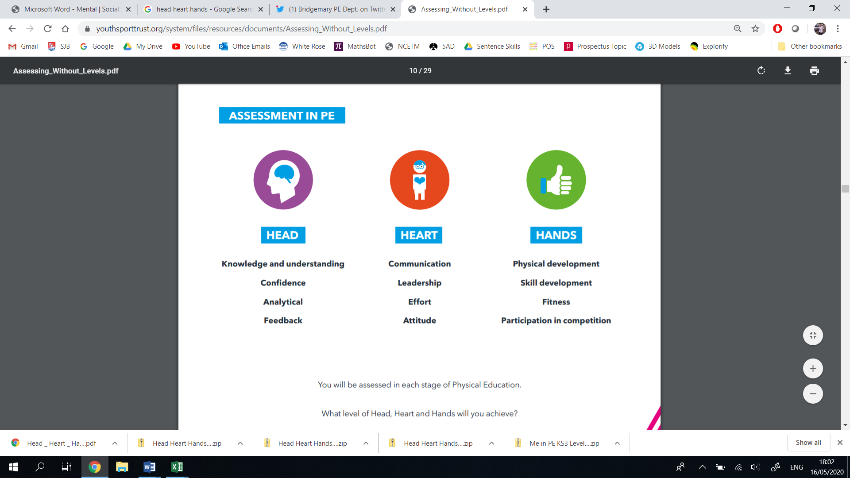
Thinking | Behaviour | Physical | Thinking | Behaviour | Physical
- Decision Making  - Confidence  - Creativity  - Analyticity | - Effort  - Communication  - Values  - Healthy Lifestyle | - Physical Development  - Skill Development  - Competitive Development  - Active Lifestyle | - Decision Making  - Confidence  - Creativity  - Analyticity | - Effort  - Communication  - Values  - Healthy Lifestyle | - Physical Development  - Skill Development  - Competitive Development  - Active Lifestyle
Year 6 |  |  | Year 5
Vocabulary: possession, modification, penetration, support, width, mobility, creativity, delay, cover, compactness, balance, territory, feint, outwit, opponent, strategy, outnumbered, transition, interception |  |  | Vocabulary: possession, modification, penetration, support, width, mobility, creativity, delay, cover, compactness, balance, territory, feint, outwit, opponent, strategy, outnumbered, transition, interception
I can confidently decide which technique/movement to use when a situation arises.  I can make effective decisions around when to attack and when to defend in a game situation.  I can think creatively to outwit an opponent in a game situation.  I can show versatility when a game has been modified.  I can identify my strengths and areas for development through verbal/video analysis.  I can offer supportive suggestions to help improve other children’s development.  I can ‘physically, mentally and emotionally connect’ to our Healthy Heart Scheme. | I can enjoy collaborating with other children, communicating my ideas and intentions effectively.  I can demonstrate leadership by leading a small group through a warm up routine.  I can demonstrate empathy through refereeing or umpiring.  I can use the rules of the game to play honestly and fairly.  I can demonstrate resilience when facing challenge.  I can demonstrate the Catholic Values in all of my actions.  I can make links between a healthy lifestyle and the lifestyle of a competitive sportsman/woman.  I am keen to pursue sport outside of the school curriculum. | I can demonstrate technique, coordination, balance, strength, flexibility and control throughout my movements.  I can demonstrate running, jumping, throwing and catching in isolation and combination, depending on the game situation.  I can outwit an opponent when attacking by using body feints, penetration, support, width, mobility and creativity effectively.  I can outwit an opponent when defending by using delay, cover, compactness and balance effectively.  I can use both feet/hands.  I can utilise space effectively when both attacking and defending in a game situation.  I enjoy competing against other children, showing Catholic and British Values throughout. | I can draw on previous knowledge to choose a skill to use when a situation arises.  I can make informed decisions around when to attack and defend in a game situation.  I can think creatively to outwit an opponent in isolation or in a game situation.  I can offer supportive suggestions to help improve other children’s development.  I can confidently modify my performance after self or peer assessment from verbal/video feedback.  I can ‘physically, mentally and emotionally connect’ to our Healthy Heart Scheme. | I can enjoy collaborating with other children, communicating ideas and intentions effectively.  I can demonstrate leadership by leading parts of a warm up.  I can demonstrate leadership and responsibility by captaining a team or group.  I can use the rules of the game to play honestly and fairly.  I can demonstrate resilience when facing challenge.  I can demonstrate the Catholic Values in all of my actions.  I can make links between a healthy lifestyle and the lifestyle of a competitive sportsman/woman.  I am keen to pursue sport outside of the school curriculum. | I can demonstrate technique, coordination, balance, strength, flexibility and control throughout my movements.  I can demonstrate running, jumping, throwing and catching in isolation and combination, depending on the game situation.  I can begin to outwit an opponent when attacking by using body feints, penetration, support, width, mobility and creativity effectively.  I can begin to outwit an opponent when defending by using delay, cover, compactness and balance effectively.  I can sometimes use both feet/hands.  I can utilise space effectively when both attacking and defending in a game situation.  I enjoy competing against other children, showing Catholic and British Values throughout.
LKS2
Thinking | Behaviour | Physical | Thinking | Behaviour | Physical
- Decision Making  - Confidence  - Creativity  - Analyticity | - Effort  - Communication  - Values  - Healthy Lifestyle | - Physical Development  - Skill Development  - Competitive Development  - Active Lifestyle | - Decision Making  - Confidence  - Creativity  - Analyticity | - Effort  - Communication  - Values  - Healthy Lifestyle | - Physical Development  - Skill Development  - Competitive Development  - Active Lifestyle
Year 4 |  |  | Year 3
Vocabulary: attack, defend, dummy, pass, receive, dribble, invasion, territory, spatial awareness, communication, possession, outwit |  |  | Vocabulary: attack, defend, dummy, pass, receive, dribble, invasion, territory, spatial awareness, communication, possession, outwit
I can decide which skill is necessary to use in isolation or a game situation.  I can attack creatively in a game situation.  I can defend creatively in a game situation.  I can confidently demonstrate an understanding of attacking and defending in invasion games.  I can confidently identify when I was successful, and how that helped me to succeed.  I can ‘physically, mentally and emotionally connect’ to our Healthy Heart Scheme | I enjoy collaborating with other children, sharing my ideas and tactics.  I can encourage my team by using effective communication.  I can follow the rules of a game, making sure I am playing honestly and fairly.  I can demonstrate resilience when facing challenge.  I can demonstrate the Catholic Values in all of my actions.  I can explain why a professional sportsman/woman needs to be physically fit.  I am keen to pursue sport outside of the school curriculum. | I can demonstrate technique, coordination, balance, strength, flexibility and control in isolation, sometimes linking them together.  I can demonstrate running, jumping, throwing and catching in isolation, sometimes linking them together.  I can recognise and use space in a game situation.  I can dribble, pass and receive effectively in a game situation.  I can keep possession for my team in a game situation.  I can identify my strongest side (left/right), and develop my weakest.  I enjoy competing against other children, showing Catholic and British Values throughout. | I can decide which skill is necessary to use in isolation or a game situation.  I can confidently understand my role as an attacker in a team, applying this in a game situation.  I can confidently understand my role as a defender in a team, applying this in a game situation.  I can develop my skills when given verbal/video feedback from other children or my teacher.  I can ‘physically, mentally and emotionally connect’ to our Healthy Heart Scheme. | I enjoy working cooperatively with my group, where we can self-manage our own small sided games.  I can encourage my team by using effective communication.  I am beginning to understand the rules of the game, playing fairly and honestly.  I can demonstrate resilience when facing challenge.  I can demonstrate the Catholic Values in all of my actions.  I can explain why a professional sportsman/woman needs to be physically fit.  I am keen to pursue sport outside of the school curriculum. | I can demonstrate technique, coordination and control in isolation, sometimes linking them together.  I can demonstrate running, jumping, throwing and catching in isolation, sometimes linking them together.  I can recognise and move into space in a game situation.  I can dribble and control a ball with increasing control in isolation, applying it into a game situation.  I can identify my strongest side (left/right), and develop my weakest.  I enjoy competing against other children, showing Catholic and British Values throughout.
KS1
Thinking | Behaviour | Physical | Thinking | Behaviour | Physical
- Decision Making  - Confidence  - Creativity  - Analyticity | - Effort  - Communication  - Values  - Healthy Lifestyle | - Physical Development  - Skill Development  - Competitive Development  - Active Lifestyle | - Decision Making  - Confidence  - Creativity  - Analyticity | - Effort  - Communication  - Values  - Healthy Lifestyle | - Physical Development  - Skill Development  - Competitive Development  - Active Lifestyle
Year 2 |  |  | Year 1
Vocabulary: target, dribbling, kicking, throwing, receiving, space, attack, defend, control, track, dodge, intercept, opponent, defence |  |  | Vocabulary: target, dribbling, kicking, throwing, receiving, space, attack, defend, control, track, dodge, intercept, opponent, defence
I can start to demonstrate some awareness of attacking and defending  I can start to demonstrate some understanding of tactics.  I can make simple decisions when playing a game.  I can recognise my strengths and areas for development | I can demonstrate effective communication by making sure everybody in my group is involved.  I enjoy participating and competing against other children.  I can communicate to my teammates in a simple game.  I can show determination to succeed.  I can demonstrate the Catholic Values in all of my actions.  I can demonstrate I am building resilience toward challenge.  I am keen to pursue sport outside of the school curriculum. | I can demonstrate fundamental movement skills to roll a ball at a target.  I can demonstrate fundamental movement skills by tracking a ball and collecting it.  I can dribble a ball with my hands and feet showing some control.  I can send and receive a ball using my fundamental movement skills.  I am creative when using and developing skills. | I can start to demonstrate some awareness of attacking and defending  I can start to demonstrate some understanding of tactics.  I can make simple decisions when playing a game.  I can recognise my strengths and areas for development | I can cooperate with a partner when playing a simple game.  I enjoy participating with other children.  I can communicate to my teammate in a simple game.  I can make simple decisions.  I can show determination to succeed.  I can demonstrate the Catholic Values in all of my actions.  I can demonstrate I am building resilience toward challenge.  I am keen to pursue sport outside of the school curriculum. | I can demonstrate fundamental movements skills to throw a ball at a target.  I can demonstrate fundamental movements skills to track and stop a ball coming towards me.  I can be creative in the way I travel with a ball.  I can dribble a ball with my hands and feet.  I can begin to catch a ball with 2 hands.

