Gymnastics
UKS2
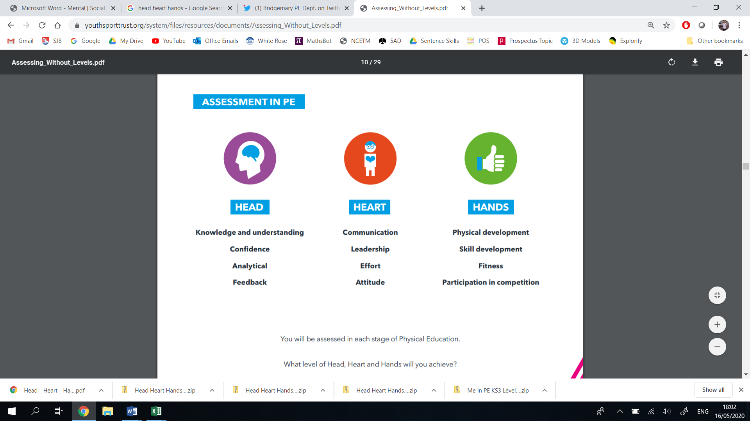
Thinking | Behaviour | Physical | Thinking | Behaviour | Physical
- Decision Making  - Confidence  - Creativity  - Analyticity | - Effort  - Communication  - Values  - Healthy Lifestyle | - Physical Development  - Skill Development  - Competitive Development  - Active Lifestyle | - Decision Making  - Confidence  - Creativity  - Analyticity | - Effort  - Communication  - Values  - Healthy Lifestyle | - Physical Development  - Skill Development  - Competitive Development  - Active Lifestyle
Year 6 |  |  | Year 5
Vocabulary: symmetric, asymmetric, synchronisation, tumble, tension, counter, composition, inversion, precision, aesthetics, momentum |  |  | Vocabulary: symmetric, asymmetric, synchronisation, tumble, tension, counter, composition, inversion, precision, aesthetics, momentum
I can confidently perform a practiced sequence in front of an audience.  I can demonstrate the confidence and competence to attempt new movements for a sequence.  I can make effective decisions for my sequence, based around the success criteria and the audience.  I can create imaginative sequences using skills I have previously learnt.  I can evaluate a performance, explaining the effectiveness of certain parts and suggesting improvements through verbal/video feedback.  I can ‘physically, mentally and emotionally connect’ to our Healthy Heart Scheme. | I can effectively explain my ideas to a group.  I can effectively suggest improvements to my or other children’s sequence.  I can show resilience and problem solving skills.  I can demonstrate leadership by leading a warm-up for a small group.  I can use ambitious vocabulary when explaining parts of a sequence.  I can demonstrate the Catholic Values in all of my actions.  I am keen to pursue sport outside of the school curriculum.  I can make links between a healthy lifestyle and the lifestyle requirements of a gymnast. | I can perform complex gymnastics movements, showing control, coordination, balance, flexibility and technique throughout.  I can link movements together showing fluency, precision and purpose.  I can use a range of skills, varying in difficulty, to create a gymnastic sequence.  I can create longer sequences by using compositional devices to improve the quality of my sequence.  I can use apparatus to support more challenging movements, showing control.  I can perform tumbles safely, showing control and technique.  I enjoy competing against other children, showing Catholic and British Values throughout. | I can confidently perform a practiced sequence in front of an audience.  I can demonstrate the confidence and competence to attempt new movements for a sequence.  I can make informed decisions for my sequence, based around the success criteria and the audience.  I can create imaginative sequences using skills I have previously learnt.  I can analyse a performance, explaining the effectiveness of certain parts and suggesting improvements through verbal/video feedback.  I can ‘physically, mentally and emotionally connect’ to our Healthy Heart Scheme. | I can explain my ideas to a group.  I can effectively suggest improvements to my or other children’s sequence.  I can show resilience and problem solving skills.  I can demonstrate leadership by leading a warm-up for a small group.  I can use ambitious vocabulary when explaining parts of a sequence.  I can demonstrate the Catholic Values in all of my actions.  I am keen to pursue sport outside of the school curriculum.  I can make connections between professional gymnastics and their lifestyle choices. | I can perform complex gymnastics movements, showing control, coordination, balance, flexibility and technique throughout.  I can link movements together showing fluency, precision and control.  I can use a range of skills, varying in difficulty, to create a gymnastic sequence.  I can create longer sequences by using compositional devices to improve the quality of my sequence.  I can use apparatus to support more challenging movements, showing control.  I can safely tumble in isolation, sometimes linking it into a sequence with fluency.  I enjoy competing against other children, showing Catholic and British Values throughout.
LKS2
Thinking | Behaviour | Physical | Thinking | Behaviour | Physical
- Decision Making  - Confidence  - Creativity  - Analyticity | - Effort  - Communication  - Values  - Healthy Lifestyle | - Physical Development  - Skill Development  - Competitive Development  - Active Lifestyle | - Decision Making  - Confidence  - Creativity  - Analyticity | - Effort  - Communication  - Values  - Healthy Lifestyle | - Physical Development  - Skill Development  - Competitive Development  - Active Lifestyle
Year 4 |  |  | Year 3
Vocabulary: symmetry, dynamics, extension, rotation, mirroring, unison, cannon, fluency, aesthetics, tension, momentum, rhythm, jump |  |  | Vocabulary: symmetry, dynamics, extension, rotation, mirroring, unison, cannon, fluency, aesthetics, tension, momentum, rhythm, jump
I can confidently perform in front of a small group.  I can demonstrate the confidence and competence to attempt modified versions of a sequence.  I can choose to adapt/modify/refine a sequence to make it more personal.  I can create imaginative sequences using skills I have previously learnt.  I can recognise what makes a good sequence, and offer suggestions to develop other children’s learning.  I can ‘physically, mentally and emotionally connect’ to our Healthy Heart Scheme. | I can collaborate and adapt my own sequence to accommodate a partner’s ability.  I can communicate effectively when working with a partner.  I can demonstrate leadership by leading a partner through a warm-up.  I can use correct vocabulary when explaining parts of a sequence.  I can demonstrate the Catholic Values in all of my actions.  I am keen to pursue sport outside of the school curriculum. | I can perform more challenging gymnastic movements, showing technique, flexibility, control and balance.  I can perform with greater fluency, linking sequences of movements together.  I can demonstrate a change of dynamics through speed, direction, levels and shape.  I can demonstrate matching and mirroring when working in unison.  I can demonstrate more complex rolls with partner support, sometimes linking them to other movements.  I enjoy competing against other children, showing Catholic and British Values throughout. | I can confidently perform in front of a small group.  I can demonstrate the confidence to attempt more challenging gymnastic movements.  I can choose and plan sequences of contrasting actions.  I can explain how flexibility and strength is developed through my actions.  I can improve my sequence through being given advice from verbal/video feedback.  I can ‘physically, mentally and emotionally connect’ to our Healthy Heart Scheme. | I can adapt my own movements to accommodate my partner’s ability.  I can communicate my ideas when working with a partner.  I can demonstrate independence by using a greater number of my own ideas for movements to respond to a task.  I can use correct vocabulary when explaining parts of a sequence.  I can demonstrate the Catholic Values in all of my actions.  I am keen to pursue sport outside of the school curriculum. | I can perform more challenging gymnastic movements, showing technique, flexibility, control and balance.  I can support my own body weight on different parts of my body.  I can demonstrate the 5 basic jumps, showing control, coordination and technique.  I can perform sequences with a greater degree of fluency and control.  I can adapt my sequence from the floor to suit different types of apparatus.  I can demonstrate basic rotary movements, like cartwheels, forward rolls and full turns.
KS1
Thinking | Behaviour | Physical | Thinking | Behaviour | Physical
- Decision Making  - Confidence  - Creativity  - Analyticity | - Effort  - Communication  - Values  - Healthy Lifestyle | - Physical Development  - Skill Development  - Competitive Development  - Active Lifestyle | - Decision Making  - Confidence  - Creativity  - Analyticity | - Effort  - Communication  - Values  - Healthy Lifestyle | - Physical Development  - Skill Development  - Competitive Development  - Active Lifestyle
Year 2 |  |  | Year 1
Vocabulary: body, tension, shape, movement, pathway, weight, support, straight, curled, relaxed, tense, movement, sequence, link |  |  | Vocabulary: body, tension, shape, movement, pathway, weight, support, straight, curled, relaxed, tense, movement, sequence, link
I can confidently perform a small sequence independently.  I can make decisions on how to travel and use my body throughout a sequence.  I can remember, repeat and explore simple actions.  I can show imagination when exploring a variety of actions.  I can recognise strengths and areas for development in my or other children’s sequence through verbal/video feedback. | I can work cooperatively with a partner.  I demonstrate a willingness to practice and improve.  I can demonstrate the Catholic Values in all of my actions.  I can explain why a gymnast needs to eat healthily, and why we should follow their example.  I am keen to pursue sport outside of the school curriculum. | I can perform various movements through different levels and speed.  I can perform gymnastic movements with coordination, control and balance.  I can support my own body weight on some different parts of my body.  I can travel on different parts of my body.  I can adapt my sequence from the floor to suit different types of apparatus. | I can confidently perform gymnastic movements independently.  I can make decisions on how to travel and use my body in a movement.  I can remember and repeat simple actions.  I can show imagination when adapting some movements.  I can say what is good about my performance, and listen to my teacher of friends when they explain how I could improve it. | I can work cooperatively with a partner.  I demonstrate a willingness to practice and improve.  I can demonstrate the Catholic Values in all of my actions.  I can explain what a gymnast would need to eat to make sure they maintain a healthy lifestyle.  I am keen to pursue sport outside of the school curriculum. | I can perform various movements through different levels and speed.  I can perform gymnastic movements with control and balance.  I can support my own body weight on my hands.  I can travel on different parts of my body.  I can tense, stretch, curl and relax my body.  I can adapt movement from the floor to suit different types of apparatus.

