Dance
UKS2
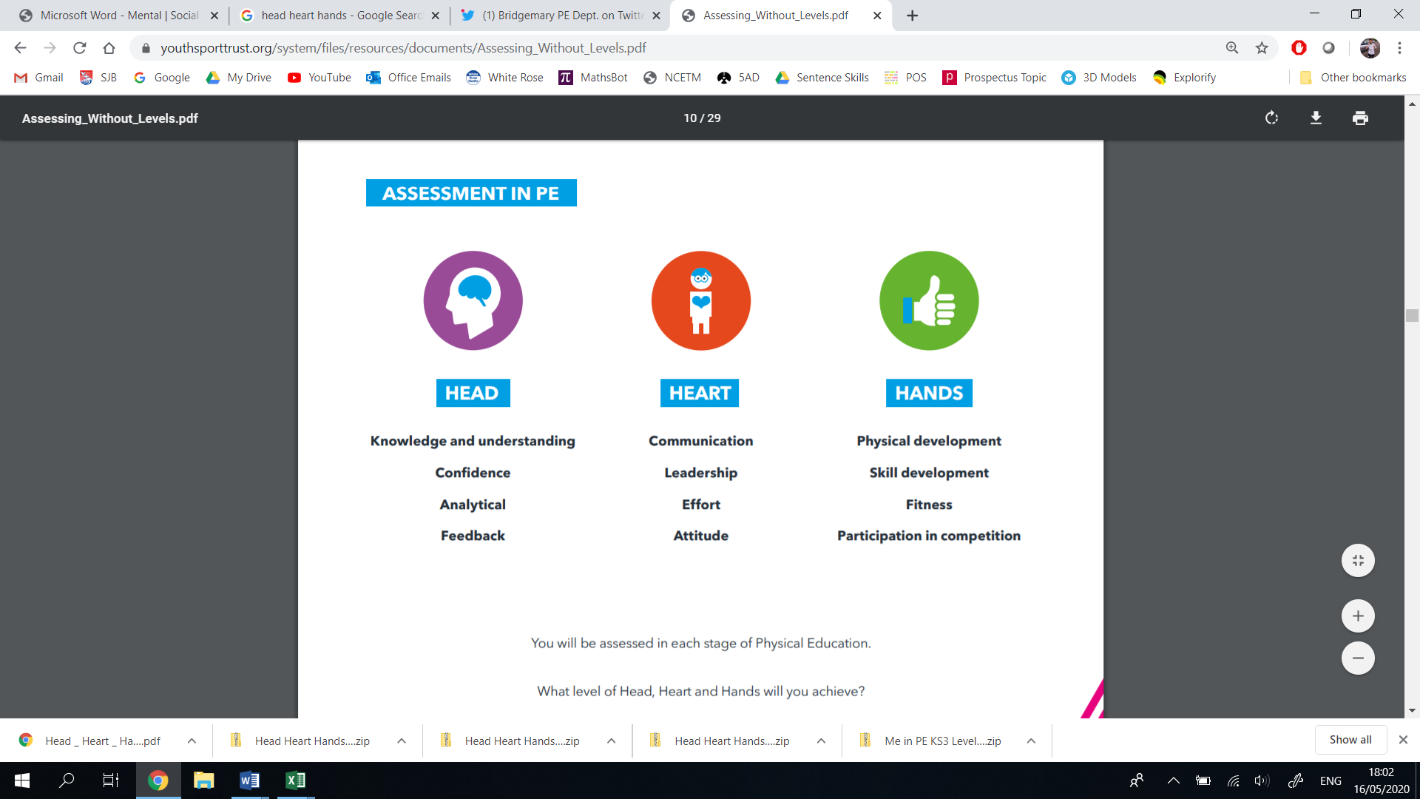
Thinking | Behaviour | Physical | Thinking | Behaviour | Physical
- Decision Making  - Confidence  - Creativity  - Analyticity | - Effort  - Communication  - Values  - Healthy Lifestyle | - Physical Development  - Skill Development  - Competitive Development  - Active Lifestyle | - Decision Making  - Confidence  - Creativity  - Analyticity | - Effort  - Communication  - Values  - Healthy Lifestyle | - Physical Development  - Skill Development  - Competitive Development  - Active Lifestyle
Year 6 |  |  | Year 5
Vocabulary: performance, audience, purpose, intent, etiquette, aesthetically, rhythm, choreograph, canon, unison, dynamics, motif, phrase, contrasting |  |  | Vocabulary: performance, audience, purpose, intent, etiquette, aesthetically, rhythm, choreograph, dynamics, expansion, contraction, phrase
I can perform with confidence, using a range of movement patterns.  I can demonstrate a creative imagination when choreographing a performance by myself or in a group.  I can make calculated decisions on how to move, appropriately linking movements to the music.  I can demonstrate an understanding of audience and purpose throughout my performance.  I can confidently modify my performance after self or peer assessment from verbal/video feedback.  I can ‘physically, mentally and emotionally connect’ to our Healthy Heart Scheme. | I can effectively communicate my ideas and interpretation of mine and others’ performances.  I can show purpose and intent when performing, linking movements and expressions to the music.  I can follow dance etiquette, by being a determined performer and respectful observer.  I can use ambitious vocabulary when describing or comparing performances.  I can make links between professional athletes and their healthy lifestyle.  I can demonstrate resilience when facing challenge.  I can demonstrate the Catholic Values in all of my actions. | I can combine flexibility, technique, control and balance to create fluent performances.  I can exaggerate dance movements and motifs using expression when performing.  I can demonstrate a precise control when changing pace, direction and levels.  I can demonstrate a fluid rhythm, beatmatching to the music.  I can use movements in combination to make an aesthetically pleasing performance.  I can perform in a competitive spirit, adhering to scoring regulations and environments. | I can perform with confidence, using a range of movement patterns.  I can demonstrate a creative imagination when choreographing a performance by myself or in a group.  I can make informed decisions on how to move, appropriately linking movements to the music.  I can demonstrate an understanding of who I am performing for, by choosing appropriate movements.  I can confidently modify my performance after self or peer assessment from verbal/video feedback.  I can ‘physically, mentally and emotionally connect’ to our Healthy Heart Scheme. | I can effectively communicate my ideas and interpretation of mine and others’ performances.  I can show purpose and intent when performing, linking movements and expressions to the music.  I can follow dance etiquette, by being a determined performer and respectful observer.  I can use ambitious vocabulary when describing or comparing performances.  I can make links between professional athletes and their healthy lifestyle.  I can demonstrate resilience when facing challenge.  I can demonstrate the Catholic Values in all of my actions. | I can combine flexibility, technique, control and balance to create fluent performances.  I can perform different styles of dance clearly and fluently.  I can demonstrate expression throughout my performances, by consciously moving to the beat.  I can demonstrate a control when changing pace, direction and levels.  I can use space effectively, moving fluidly from one position to another.  I can perform in a competitive spirit, adhering to scoring regulations and environments.
LKS2
Thinking | Behaviour | Physical | Thinking | Behaviour | Physical
- Decision Making  - Confidence  - Creativity  - Analyticity | - Effort  - Communication  - Values  - Healthy Lifestyle | - Physical Development  - Skill Development  - Competitive Development  - Active Lifestyle | - Decision Making  - Confidence  - Creativity  - Analyticity | - Effort  - Communication  - Values  - Healthy Lifestyle | - Physical Development  - Skill Development  - Competitive Development  - Active Lifestyle
Year 4 |  |  | Year 3
Vocabulary: performance, rhythm, choreograph, formation, canon, unison, dynamics, character, narrative |  |  | Vocabulary: performance, rhythm, choreograph, formation, canon, unison, dynamics, character, narrative
I can respond creatively to a range of stimuli related to a character or a narrative.  I can choose creative movements which link to a character or narrative.  I can confidently perform and improvise my dance performances.  I can evaluate mine and others’ performances, using appropriate language.  I can ‘physically, mentally and emotionally connect’ to our Healthy Heart Scheme. | I can share and listen to ideas to help create a sequence.  I can respectfully watch and suggest improvements to other children’s’ performances.  I can communicate clearly by using correct vocabulary.  I can make links between lifestyle choices and a professional dancer.  I can demonstrate aspects of resilience facing challenge.  I can demonstrate the Catholic Values in all of my actions. | I can demonstrate flexibility, technique, control and balance in my performance, sometimes linking them together.  I can demonstrate formation, cannon and unison to form a dance.  I can demonstrate precision in some of my movements.  I can copy or invent methods of movement, linking it to a character or narrative.  I can perform in competitive situations, following rules and scoring systems. | I can choose creative movements which link to a character or narrative.  I can confidently repeat, remember and refine movements.  I can recognise the expressive features of dance through my and other children’s performances.  I can confidently talk about strengths and weaknesses of my own performance.  I can ‘physically, mentally and emotionally connect’ to our Healthy Heart Scheme. | I can share and listen to ideas to help create a sequence.  I can recognise components of a performance and explain confidently.  I can use correct vocabulary when describing my own or other children’s performances.  I can demonstrate an understanding for how a professional dancer needs to live a healthy lifestyle.  I can demonstrate aspects of resilience facing challenge.  I can demonstrate the Catholic Values in all of my actions. | I can demonstrate flexibility, technique, control and balance in my performance.  I can demonstrate cannon and unison in small groups.  I can perform copied or partly invented performances clearly and fluently.  I can count to the beat to keep in time with the music.  I can perform in competitive situations, following rules and scoring systems.
KS1
Thinking | Behaviour | Physical | Thinking | Behaviour | Physical
- Decision Making  - Confidence  - Creativity  - Analyticity | - Effort  - Communication  - Values  - Healthy Lifestyle | - Physical Development  - Skill Development  - Competitive Development  - Active Lifestyle | - Decision Making  - Confidence  - Creativity  - Analyticity | - Effort  - Communication  - Values  - Healthy Lifestyle | - Physical Development  - Skill Development  - Competitive Development  - Active Lifestyle
Year 2 |  |  | Year 1
Vocabulary: performance, expression, beat, pathway, direction, movement, dynamics, timing, shapes, balance, agility, co-ordination, unison |  |  | Vocabulary: performance, expression, beat, pathway, direction, movement, dynamics, timing, shapes, balance, co-ordination
I can choose creative movements to express a feeling, mood or idea.  I can creatively adapt a repeated dance phrase.  I can perform with confidence.  I can say what I liked about my or other children’s performance.  I can ‘physically, mentally and emotionally connect’ to our Healthy Heart Scheme. | I can communicate effectively with a partner when performing in unison.  I can describe why parts of a performance were good.  I can observe closely when other children are performing.  I can explain why a dancer needs to be fit and healthy.  I can show I am determined to succeed.  I can demonstrate the Catholic Values in all of my actions. | I can use my fundamental movement skills whilst performing, sometimes linking them together.  I can demonstrate balance, agility and co-ordination in my performances.  I can remember and repeat dance phrases which link to a character or narrative.  I can use counts to help me move to the music. | I can choose creative movements to express a feeling, mood or idea.  I can demonstrate confidence in my fundamental movement skills.  I can provide feedback to others after watching their performance.  I can ‘physically, mentally and emotionally connect’ to our Healthy Heart Scheme. | I can show an interest in performing to an audience.  I can describe parts of a performance.  I can observe closely when other children are performing.  I can describe what a good dancer needs to eat to stay healthy.  I can describe why a dancer needs to exercise.  I can show an interest in my learning.  I can demonstrate the Catholic Values in all of my actions. | I can use my fundamental movement skills whilst performing.  I can use different parts of my body in isolation and together.  I can demonstrate balance and co-ordination in my performances.  I can remember and repeat dance phrases which link to a character or narrative.  I can adapt a simple repeated phrase.

