Athletics
UKS2
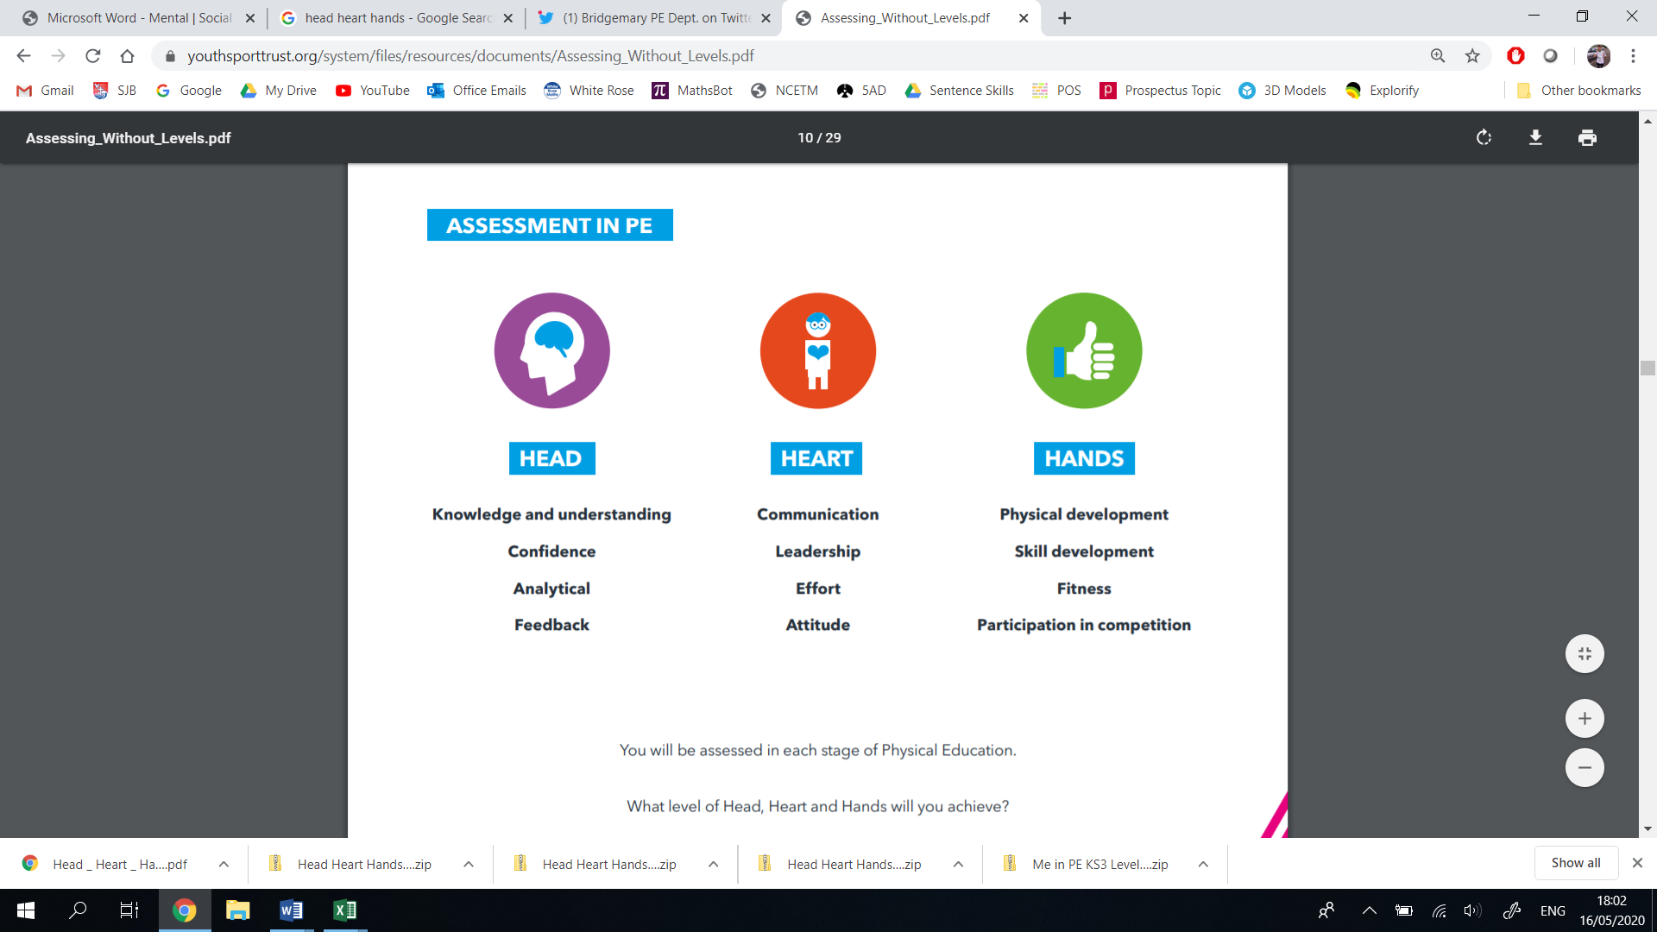
Thinking | Behaviour | Physical | Thinking | Behaviour | Physical
- Decision Making  - Confidence  - Creativity  - Analyticity | - Effort  - Communication  - Values  - Healthy Lifestyle | - Physical Development  - Skill Development  - Competitive Development  - Active Lifestyle | - Decision Making  - Confidence  - Creativity  - Analyticity | - Effort  - Communication  - Values  - Healthy Lifestyle | - Physical Development  - Skill Development  - Competitive Development  - Active Lifestyle
Year 6 |  |  | Year 5
Vocabulary: pace, momentum, elevation, trajectory, plyometric, drive phrase, endurance, upsweep, downsweep, communication, angle, bodyweight, shift, follow-through, plant, reaction time |  |  | Vocabulary: pace, momentum, elevation, trajectory, plyometric, drive phrase, endurance, upsweep, downsweep, communication, angle, bodyweight, shift, follow-through, plant, reaction time
I can make decisions when competing, like pacing myself or increasing my speed.  I can confidently compete in all aspects of athletics, applying my previously learnt skills.  I can differentiate between events, choosing to use particular skills or ideas to appropriately suit.  I can creatively adapt my skills to participate in various events.  I know and understand the rules of a variety of athletic events.  I can evaluate my own and other children’s performance, suggesting improvements to develop learning through verbal/video feedback. | I can work effectively in a group, communicating strategy and tactics clearly.  I can take on different roles in a group activity.  I can demonstrate a willingness to work on a personal target, showing perseverance.  I can demonstrate leadership by leading a small warm up, based around stamina, power and strength.  I can describe technique using ambitious vocabulary.  I can be supportive to those children of different abilities.  I can show Catholic and British Values in my actions. | I can jump greater distances by using strength, control and speed.  I can demonstrate control, speed, strength and stamina when running.  I can throw a javelin accurately over greater distances using the correct technique, grip and action.  I can pace my efforts well, assimilating between distance or time related events  I can positively transfer skills and knowledge from the PE curriculum to help me succeed in athletic style events.  I enjoy competing in athletic style events against other children.  I can follow an athlete’s model of living a healthy and active lifestyle. | I can make decisions when competing, like pacing myself or increasing my speed.  I can confidently compete in all aspects of athletics, applying my previously learnt skills.  I can differentiate between events, choosing to use particular skills or ideas to appropriately suit.  I can creatively adapt my skills to participate in various events.  I know and understand the rules of most of the athletic events.  I can analyse my own and other children’s performance, suggesting improvements to develop learning through verbal/video feedback. | I can work effectively in a group, communicating strategy and tactics clearly.  I can organise and judge events for other children.  I can demonstrate a willingness to work on a personal target, showing perseverance.  I can demonstrate leadership by leading a small warm up, based around stamina, and strength.  I can describe technique using ambitious vocabulary.  I can be supportive to those children of different abilities.  I can show Catholic and British Values in my actions. | I can jump greater distances by using strength, control and speed.  I can demonstrate control, speed, strength and stamina when running.  I can throw a javelin with improving accuracy, using the correct technique, grip and action.  I can pace my efforts well, assimilating between distance or time related events.  I can positively transfer skills and knowledge from the PE curriculum to help me succeed in athletic style events.  I enjoy competing in athletic style events against other children.  I can follow an athlete’s model of living a healthy and active lifestyle.
LKS2
Thinking | Behaviour | Physical | Thinking | Behaviour | Physical
- Decision Making  - Confidence  - Creativity  - Analyticity | - Effort  - Communication  - Values  - Healthy Lifestyle | - Physical Development  - Skill Development  - Competitive Development  - Active Lifestyle | - Decision Making  - Confidence  - Creativity  - Analyticity | - Effort  - Communication  - Values  - Healthy Lifestyle | - Physical Development  - Skill Development  - Competitive Development  - Active Lifestyle
Year 4 |  |  | Year 3
Vocabulary: sprint, run, pace, endurance, conservation, consistency, accuracy, elevation, flightpath, plant |  |  | Vocabulary: sprint, run, pace, endurance, conservation, consistency, accuracy, elevation, flightpath, plant
I can make decisions when competing, like sprinting or endurance running.  I can confidently compete in all aspects of athletics, by running, jumping and throwing.  I can understand how different events require different skills or approaches.  I can creatively adapt my skills to participate in various events.  I know the rules of a variety of athletic events.  I can evaluate my own and other children’s performance, suggesting why it was successful using verbal/video feedback. | I can work effectively in a group, communicating mu ideas clearly.  I can take on different roles in a group activity.  I can demonstrate a willingness to work on a personal target, showing perseverance.  I can demonstrate leadership by leading a small warm up, based around speed.  I can describe technique using correct vocabulary.  I can be supportive to those children of different abilities.  I can show Catholic and British Values in my actions. | I can jump increasing distances by using small run-ups.  I can demonstrate a consistent technique when jumping, using speed, strength and control.  I can run at different speeds, taking into account distance and time.  I can throw a javelin accurately toward a target, using the correct technique, grip and action.  I can positively transfer skills and knowledge from the PE curriculum to help me attempt a variety of events.  I enjoy competing in athletic style events against other children.  I can follow an athlete’s model of living a healthy and active lifestyle. | I can make decisions about my running speed when linking it to an athletic event.  I can confidently create short jumping sequences, sharing them with other children.  I can understand how different events require different skills or approaches.  I know some of the main rules around athletics.  I can express my own strengths and areas for development, recognising what I could improve. | I can work effectively in a group, explaining my ideas.  I can demonstrate a willingness to participate in team relay events.  I can demonstrate a willingness to practice and improve, showing perseverance.  I can describe events and equipment using the correct vocabulary.  I can be supportive to those children of different abilities.  I can show Catholic and British Values in my actions. | I can jump increasing distances by using small run-ups.  I can demonstrate a consistent technique when jumping, using speed and control.  I can run at different speeds, by pacing myself over longer distances.  I can throw a variety of objects accurately toward a target, using the correct technique.  I can positively transfer my fundamental movement skills to help my participate in athletic events.  I enjoy competing in athletic style events against other children.  I can follow an athlete’s model of living a healthy and active lifestyle.
KS1 – Fundamental Movement Skills
Thinking | Behaviour | Physical | Thinking | Behaviour | Physical
- Decision Making  - Confidence  - Creativity  - Analyticity | - Effort  - Communication  - Values  - Healthy Lifestyle | - Physical Development  - Skill Development  - Competitive Development  - Active Lifestyle | - Decision Making  - Confidence  - Creativity  - Analyticity | - Effort  - Communication  - Values  - Healthy Lifestyle | - Physical Development  - Skill Development  - Competitive Development  - Active Lifestyle
Year 2 |  |  | Year 1
Vocabulary: speed, distance, accuracy, run, jump, leap, throw, underarm, overarm, technique, strength, grip, combination |  |  | Vocabulary: speed, distance, accuracy, run, jump, throw, underarm, overarm, technique, strength, grip, hop, leap, land
I can make decisions about how to use my body parts when running, jumping or throwing.  I can understand that running for speed and running for distance require me to change my running pace.  I can make links between some athletic events that contain the same skills.  I know some rules for basic athletic events.  I use my understanding to help me improve my own performances in running events. | I can work cooperatively with a partner.  I can demonstrate a willingness to practice and improve.  I can demonstrate teamwork skills by participating in team relay races.  I can explain what happens in some athletic events, using the correct vocabulary.  I show Catholic and British Values in my actions.  I can communicate my ideas by using correct vocabulary. | I can run for longer periods of time at an appropriate pace for distance.  I can demonstrate running for speed and running for distance by adjusting my running pace.  I can demonstrate exercise for a sustained period of time.  I can combine running and jumping with control and balance.  I can master the basic fundamental skills by performing running, jumping and throwing activities with increasing agility, balance, coordination and control.  I enjoy competing in mini-events either by myself or with a partner. | I can make decisions about what body parts to use when running.  I can make decisions about what body parts to use when jumping.  I can make decisions about what body parts to use when throwing.  I can confidently develop my fundamental movement skills by practicing them in isolation.  I can name some of athletic events, using the correct vocabulary.  I can say what I am doing and what I am trying to achieve. | I can work cooperatively with a partner.  I can demonstrate a willingness to practice.  I show Catholic and British Values in my actions.  I can communicate my ideas by using correct vocabulary. | I can run fast over shorter distances, showing speed and control.  I can change direction quickly, showing control and balance.  I can demonstrate an effective use of my arms and legs to drive me forward when running and jumping.  I can demonstrate a basic push throw.  I can demonstrate a basic pull throw.  I can demonstrate a fling throw.  I can demonstrate basic take offs and landings from one or two feet.

