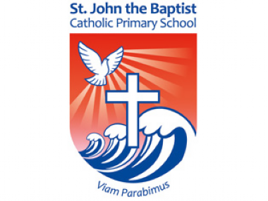

Good Shepherd Sunday
Take some time to reflect on Vocations Sunday. Pope Francis wants us to remember 5 words when thinking about vocation. Complete a task each day to understand what these things mean.
 | Things to remember… | Why? | How?
Monday | Gratitude | - Our vocation comes from Jesus’ love for us, which we perhaps realise in stormy times.  - We show gratitude – we thank Jesus for his call to us. | Doctors, nurses and others that work for the NHS are facing a tricky time in their vocation.  Send a thank card to a local hospital (or a NHS worker you know) to thank them for their hard work.
Tuesday | Encouragement | - The disciples see Jesus on the water. The think he’s a ghost and are filled with fear.  - Jesus gives encouragement that we can use on our vocational journey in life: “Take heart, it is I; have no fear.” | Reflect on a time when you succeeded and the steps you took, and also a time when you failed and what you learned.  Create a rhyme or a short song to encourage others who might need it.
Wednesday | Courage | - We can find it difficult to say “yes” to Jesus, but he knows the questions, doubts and fears in our heart.  - We can have courage, knowing Jesus is by our side, remembering “Take heart, it is I; have no fear.” | Find an example of when someone faced their fears in the Bible, a book or a film. How did they do it?  What advice would you give to them?  Write a text message to this character encouraging them to show courage.
Thursday | Fatigue | - All vocations come with responsibilities, which can be difficult.  - When fatigue or tiredness makes us start to sink, Jesus helps us, like he helped Peter walk on water. | Create a colourful piece of art for your front window to cheer up people who might feel tired of the current situation.
Friday | Praise | - When Jesus boards the boat, the winds die down.  - Jesus is stretching his hand out to us always - take it!  - Even in stormy times we must praise God for the wonderful things he does for us. | Share a prayer. We join in prayer when we attend Mass and often people take some quiet time to pray themselves. But there are different ways to pray.  You could take time for quiet prayer, meditate using the catholic mediation music on our website or sing a hymn. We would love for you to share your prayers! Email them to our school office on office@sjb.solihull.sch.uk or tweet them if you can, tagging @SJBsolihull

