Saints and Scripture in Catholic Social Teaching
CST Principle and Virtues Link | Saint | Scripture | Important Dates
Dignity of the Human Person  Virtues  Compassionate & Loving  Attentive & Discerning | 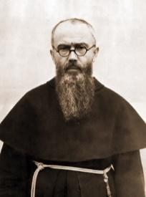  St. Maximillian Kolbe Founded monasteries in Japan and India  Provided shelter for refugees, and Jews  A martyr in the German death Camp of Auschwitz during World War II by volunteering to take the place of a man with a family | Before I formed you in the womb, I knew you.  Jeremiah 1:5  Then God said, ‘And now we will make human beings; they will be like us and resemble us.’ So God created human beings, making them to be like himself.  Genesis 1: 26-27 | Migrants and Refugees (3 Dec)  Prisoners and their families. (esp. Prisons Week 2nd week in Oct)  Human Life (Day for Life last Sunday in July)
Family and Community  Virtues  Compassionate and Loving | 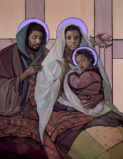  The Holy Family  The Holy Family (Jesus, his mother, the Blessed Virgin Mary, and his foster father, Saint Joseph) are the ultimate model for Christian families | So in Christ we, though many form one body and each member belongs to all the others. We have different gifts according to the gift given to each of us  Romans 12: 5-6  You shall love your neighbour as yourself  Matthew 22: 39 | The Holy Family (Sunday after Christmas)  Christian Unity (esp. Octave of Prayer to 25 Jan)  The Church (esp. Pentecost)
Solidarity and the Common Good  Virtue  Learned & Wise  Faith-filled & Hopeful | 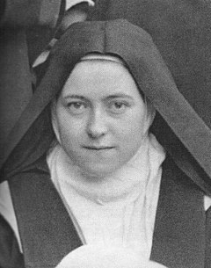  St. Therese  of Lisieux  Taught that through small, loving actions we can deliver God’s love to the world.  This teaching is called the ‘Little Way’  Each year, we are invited to participate in ‘Little Way Week’ which is an initiative that encourages people to do seven small actions – one a day for a week – to witness to their faith through service | If one part suffers, every part suffers with it; if one part is honoured, every part rejoices with it.  1 Corinthians12:26  And the King will answer them, ‘Truly, I say to you, as you did it to one of the least of these my brothers, you did it to me.’  Matthew 25:40 | Day of Prayer for Peace 2nd Sun Ordinary Time  The Needy and Hungry of the World (esp. Lent Fast Day 1st Fri in Lent)
Rights and Responsibilities  Virtues  Curious and Active | 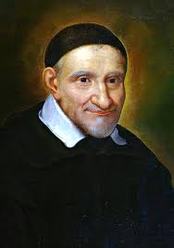  St. Vincent de Paul  Spent his life preaching missions to and providing relief to the poor  Established hospitals Extended his concern and ministry to convicts  Founded the Ladies of Charity, a lay institute of women, to help, as well as a religious institute of priests - the Congregation of Priests of the Mission, commonly referred to now as the Vincentians | Seek justice, rescue the oppressed, defend the orphan, plead for the widow.  Isaiah 1:16  Speak up for those who cannot speak for themselves, for the rights of all who are destitute. Speak up and judge fairly; defend the rights of the poor and needy.  Proverbs 31:8-9 | The Sick and those who care for them (World day of prayer for the Sick 11 Feb)  The Right Use of the Media (esp. World Communications Day 7th Sun of Easter)  Oppression and Denial of Human Rights (esp. on St. John Fisher & St. Thomas More 22 June)
Option for the Poor and Vulnerable  Virtues  Intentional & Prophetic | 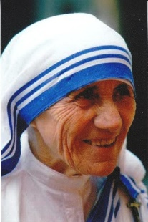  St. Mother  Teresa  of Calcutta  Established a religious community, Missionaries of Charity, dedicated to the service of the poorest of the poor  Formed the Co-Workers of Mother Teresa and the Sick and Suffering Co-Workers  Known for her spirit of prayer, simplicity, sacrifice and her apostolate of humble works of love | The spirit of the Lord is on me, for he has anointed me to bring the good news to the afflicted. He had sent me… to let the oppressed go free.  Luke 4:18  Blessed is the poor, theirs is the Kingdom of God  Luke 6: 20 | Migrants and Refugees (3 Dec)  The Needy and Hungry of the World (esp. Lent Fast Day 1st Fri in Lent)  Victims of Human Trafficking (esp. St. Josephine Bakhita 8 Feb)
Stewardship of God’s Creation  Virtues  International & Prophetic | 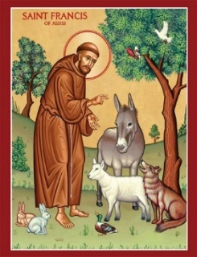  St. Francis of Assisi  Patron saint of animals and the environment.  Known for his compassion and for his deep connection to all beings particularly the animal kingdom  He cared for the sick and the poor  He believed all creatures were his brothers and sisters under God | You laid the foundation of the earth in the beginning, and the heavens are the work of your hands.  Hebrews 1:10  The Lord God took the man and put him in the Garden of Eden to work it and take care of it.  Genesis 2: 15 | The Harvest, the Fruits of Human Work, and the Reverent Use of Creation  The Season of Creation (1 September-4 October) (esp. Day of Prayer for Creation 1 September)  Prayers giving thanks and praise to God for creation and their gifts  Psalms of Creation  St Francis' Canticles of Creation
The Dignity of Work  Virtues  Attentive & Discerning | 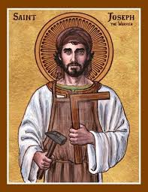  St. Joseph  the worker  Patron saint of workers  St. Joseph was a carpenter & is often depicted with either the tools of his trade to signify that he was a worker | Go and work in my vineyard and I will pay you whatever is right.  Matthew 20: 4  Whatever you do, work heartily, as for the Lord and not for human masters.  Colossians 3:23 | The Unemployed (esp. Sunday before 1st Sun of Lent)  Human Work (esp. on St. Joseph the Worker 1 May)

