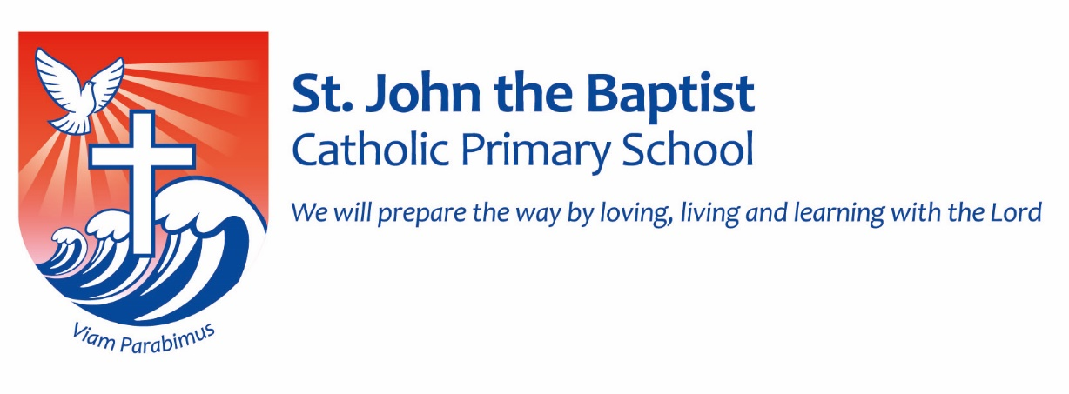

Celebrating Equality and Diversity
St. John the Baptist Catholic Primary School endeavours to improve the lives of children, young people and families. We celebrate equality and diversity and take steps to prevent all kinds of bullying and discrimination. In doing so, we believe that children will achieve more at school and our community will be happier and more successful.
The Equality Duty 2011 requires that public bodies:
- Have due regard to the need to eliminate discrimination
- Advance equality of opportunity
- Foster good relations between different people when carrying out their activities

